**Module 5: Assignment 2 User Authentication**

Saurabh Verma

Arizona State University

IFT 598: Middleware Programming & Database Security

Professor. Dinesh Sthapit

November 05, 2022

**Part 1: User Start project:**

Below are the screenshots of code in VS Code:

userModel.js file:

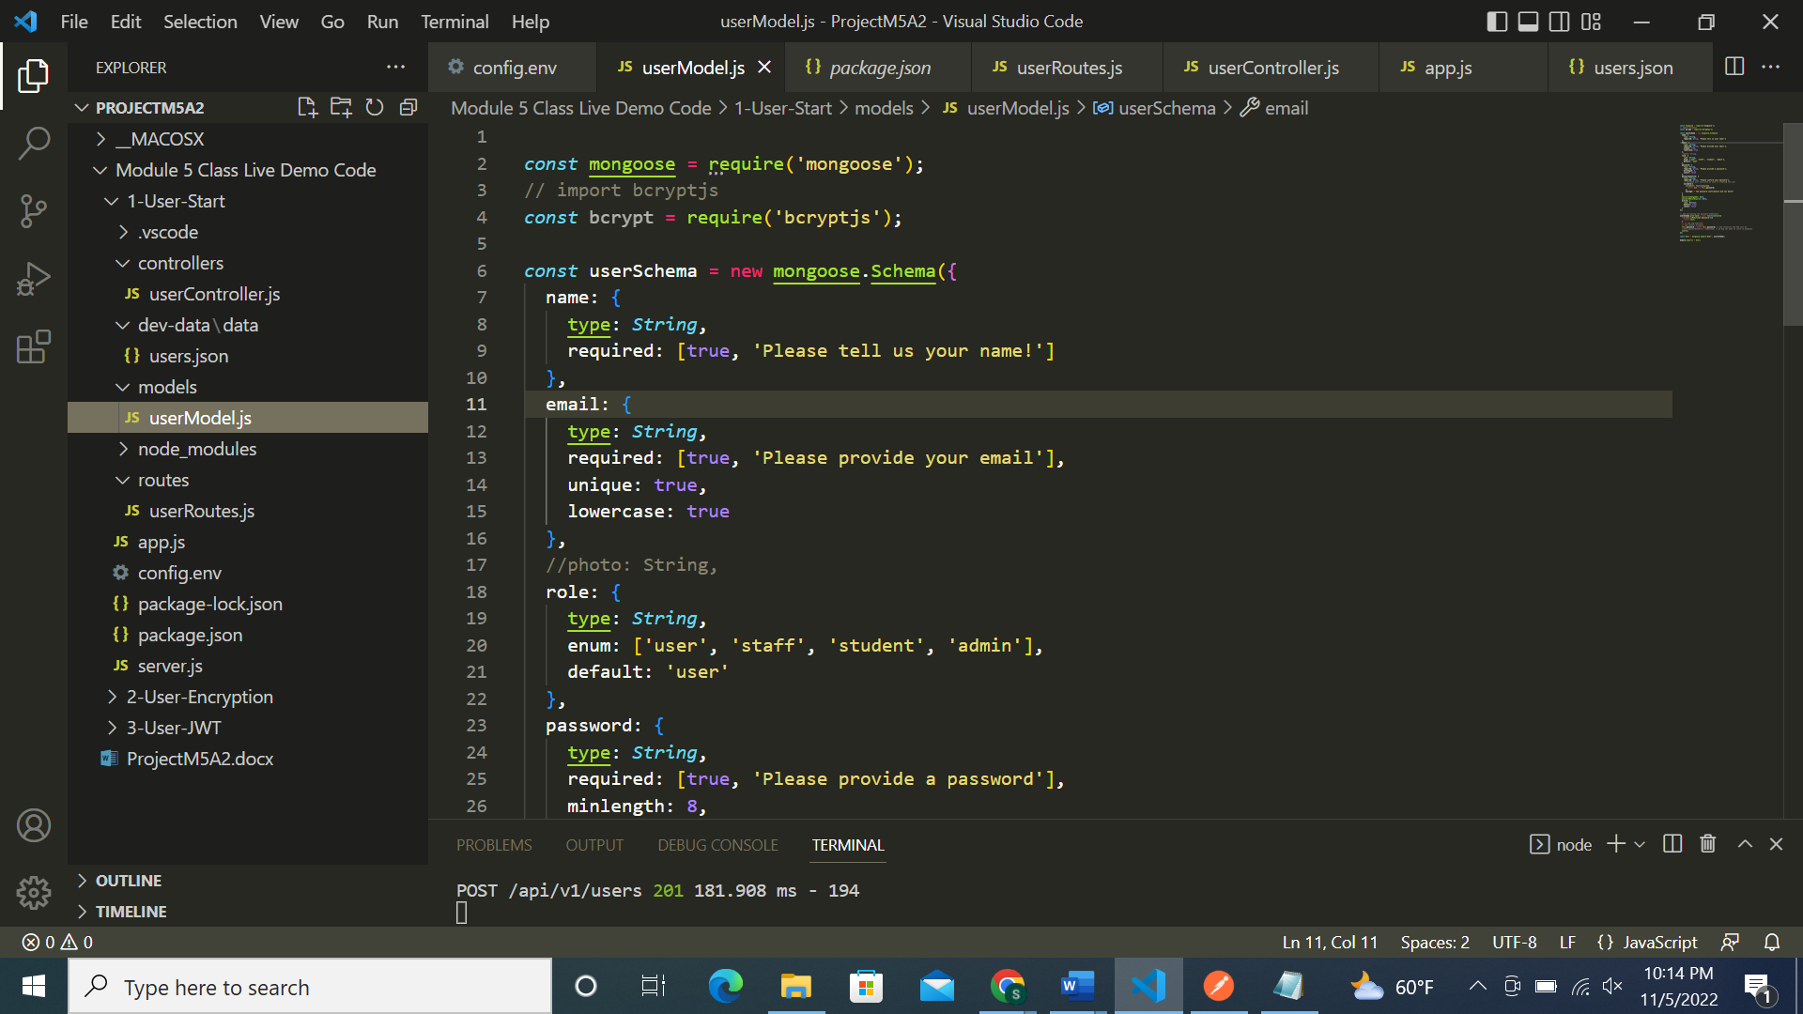

Config.env file:

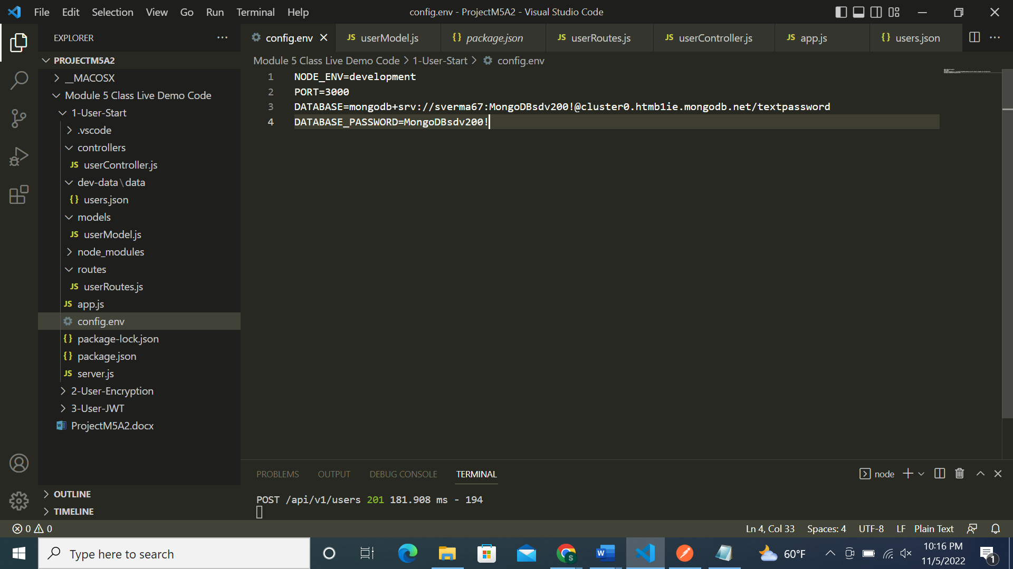

App.js file:

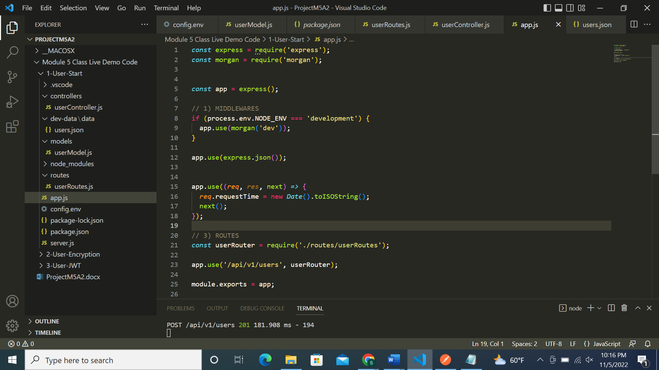

userRoutes.js file:

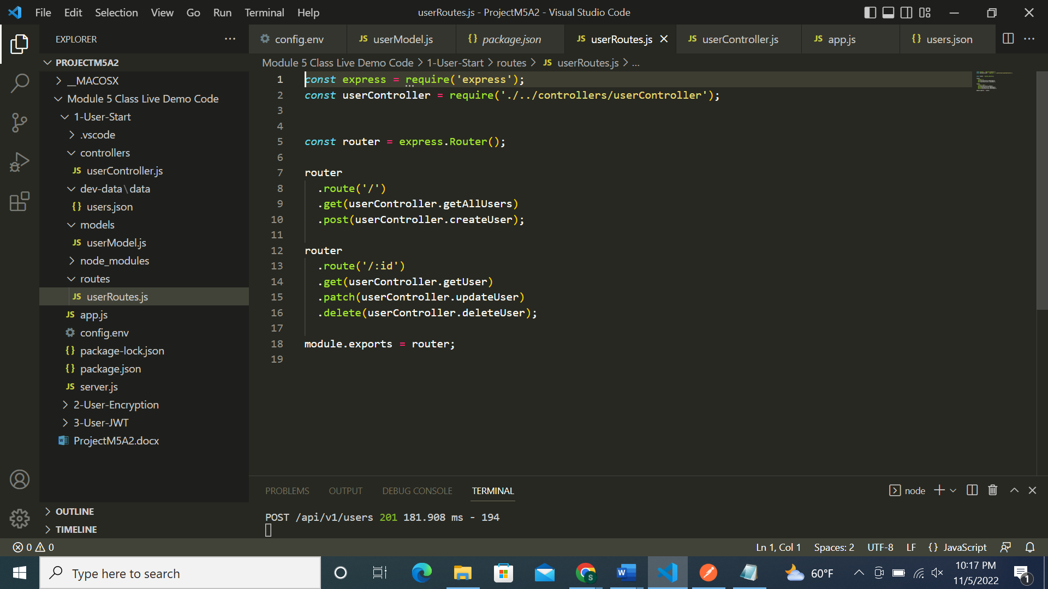

Screenshots of Postman requests:

POST request successful for first record:

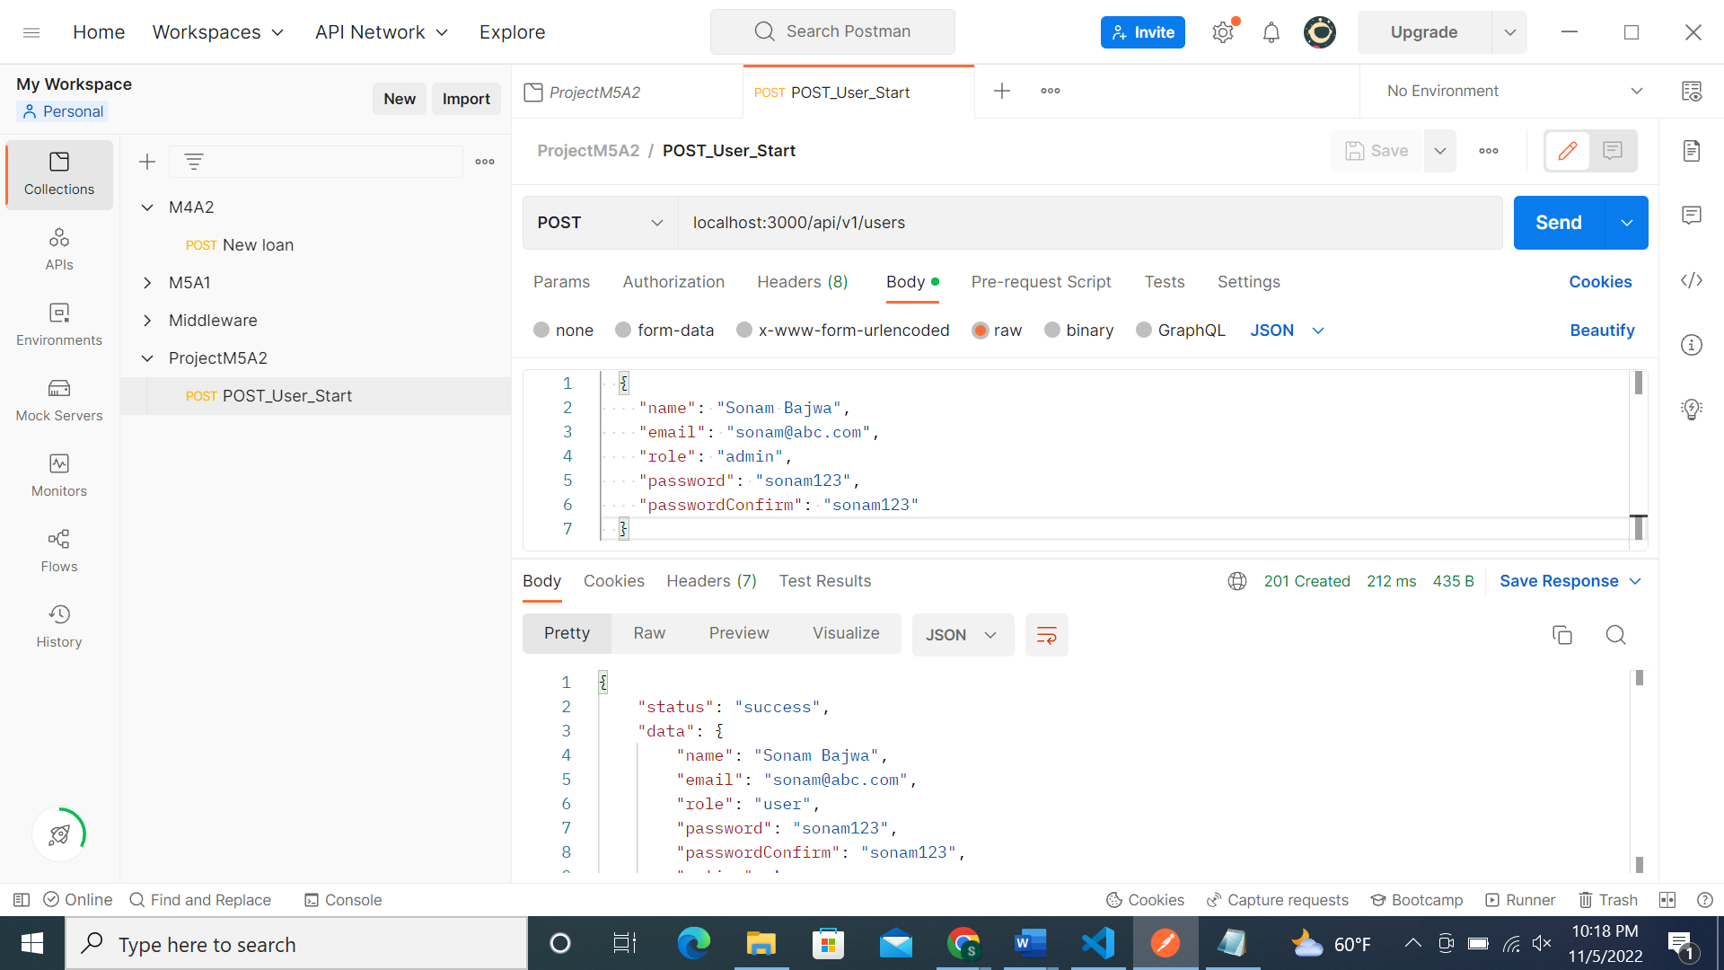

POST request successful for 2nd record:

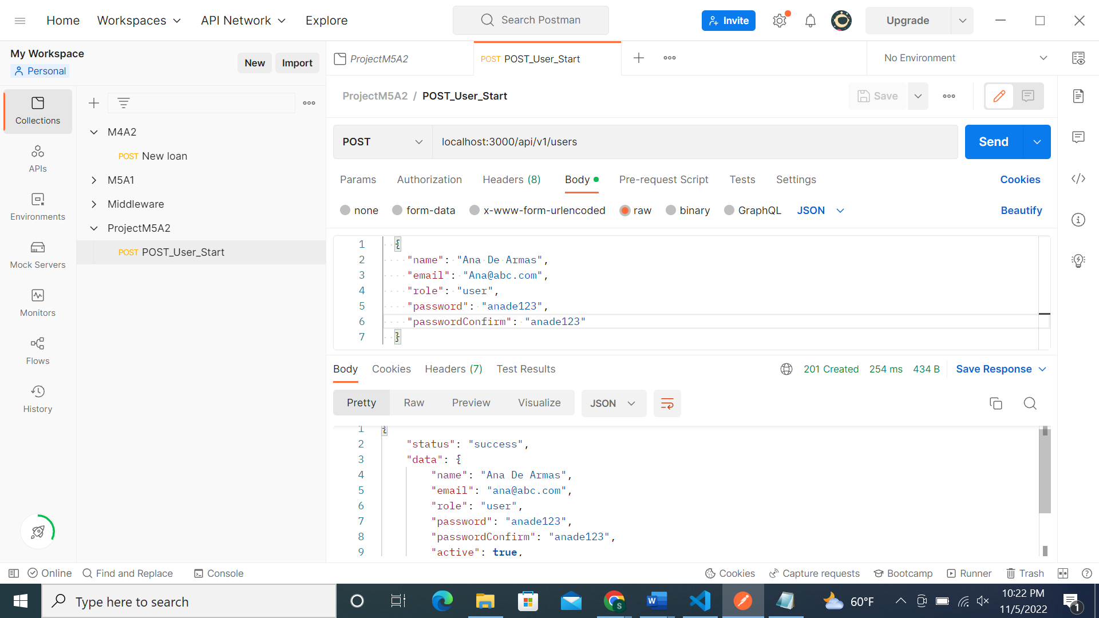

Similarly we will insert in total 5 records:

MongoDB screenshot of 5 records in textpassword table:

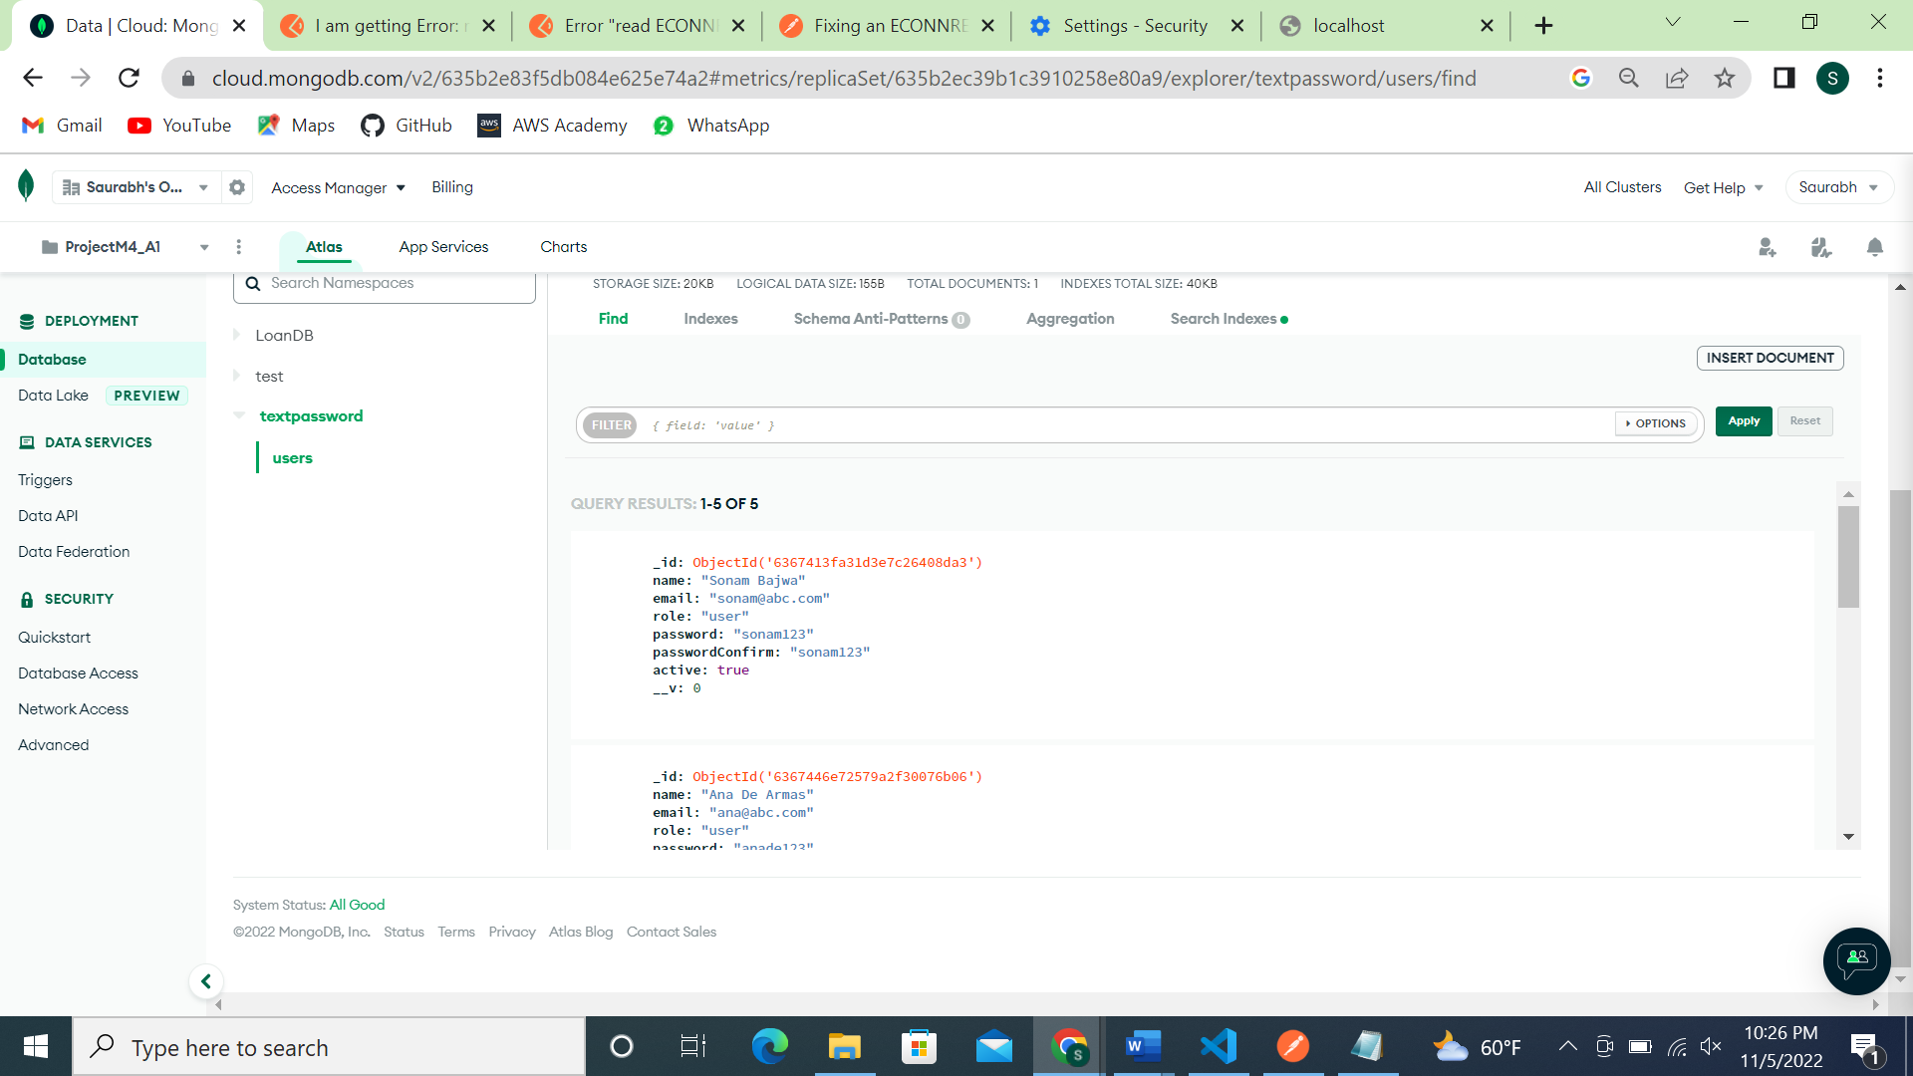

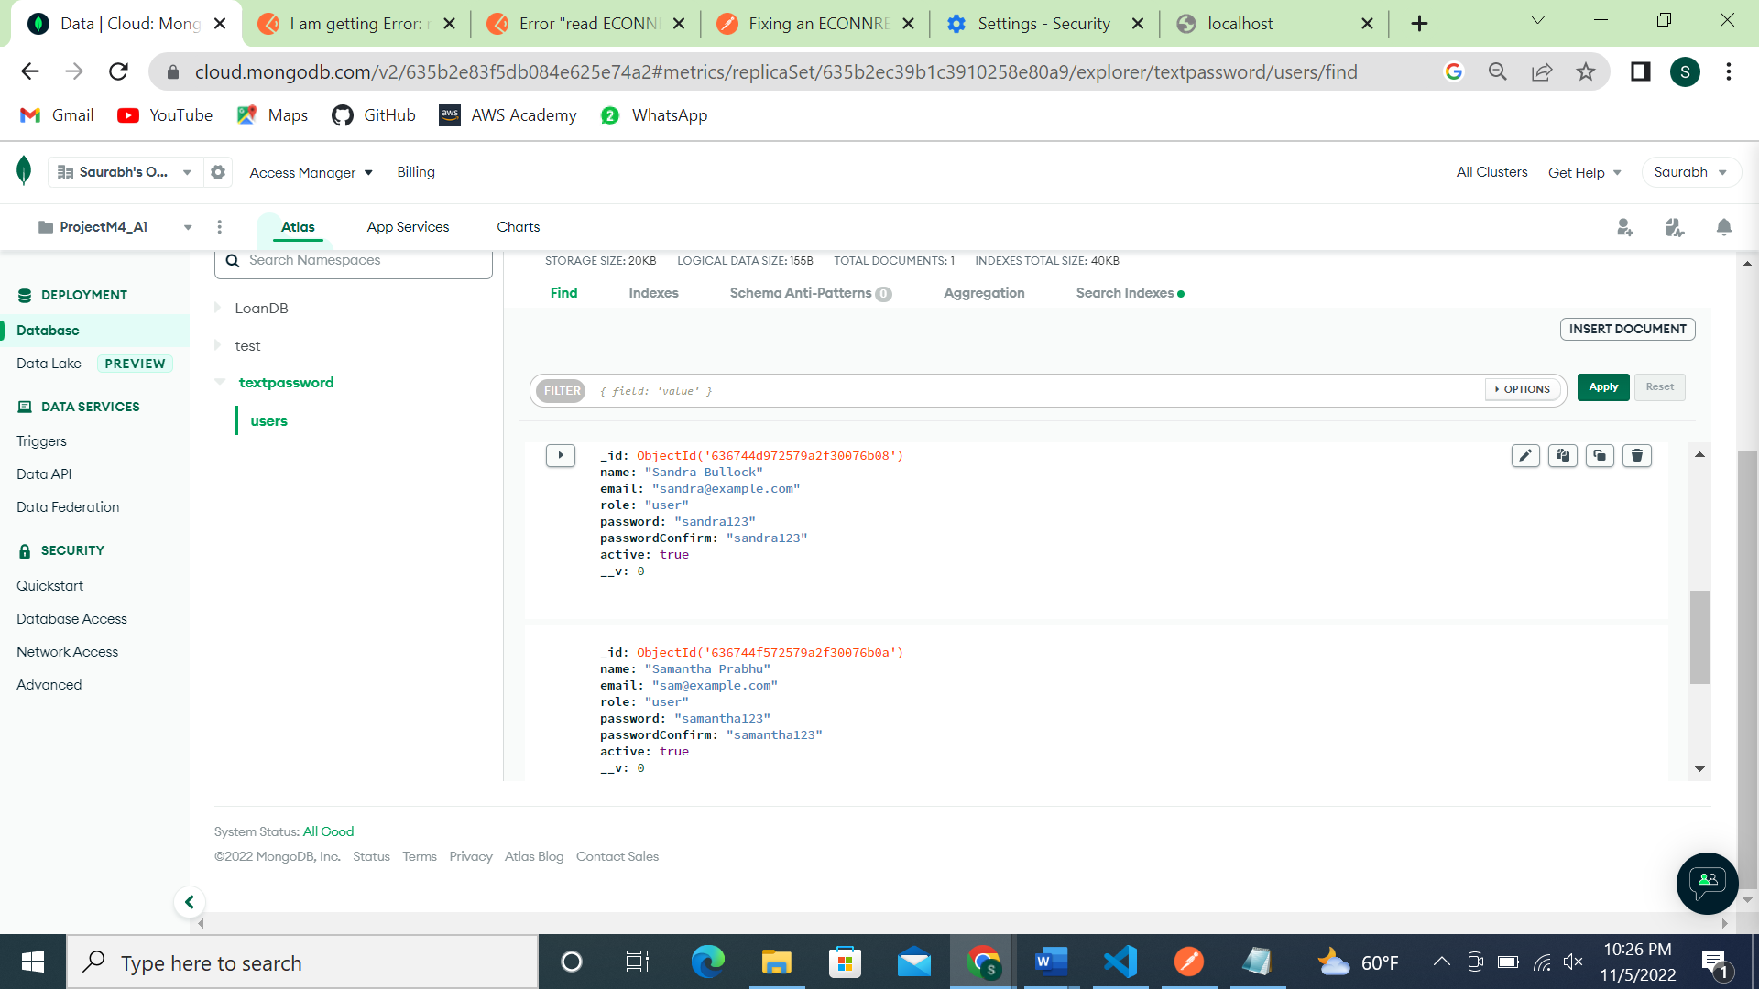

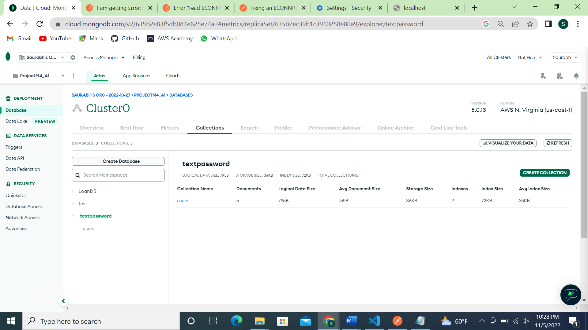

Part 2: User-encrypted file:

Screenshot of code:

Config.env file:

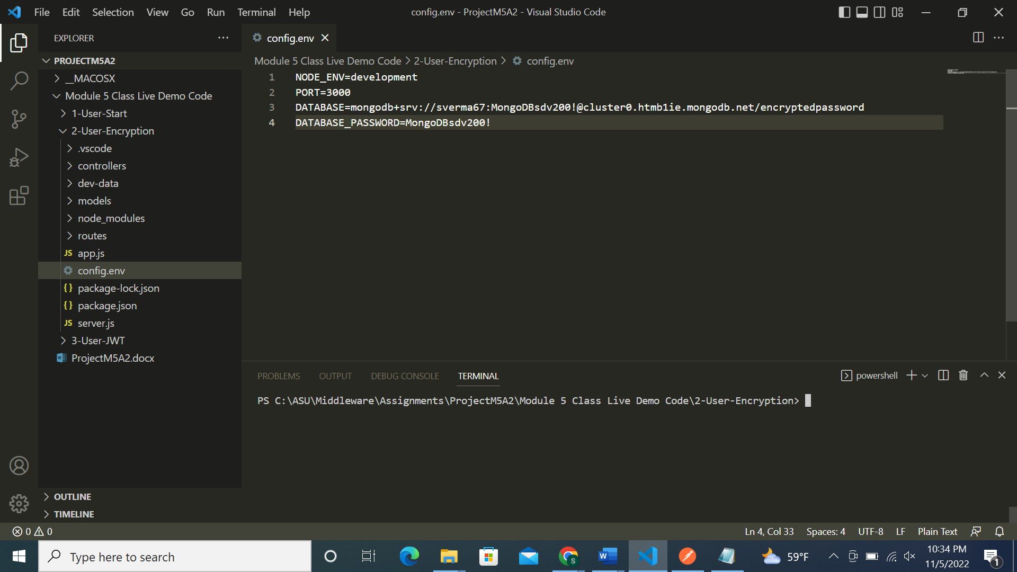

Server.js file:

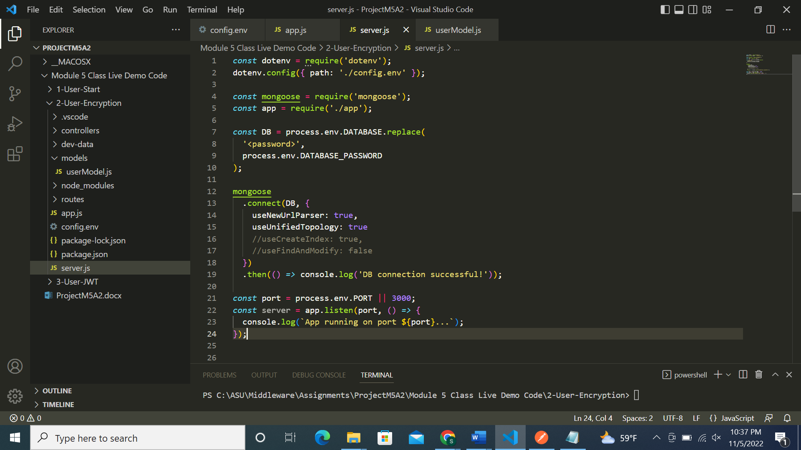

Usermodel.js file:

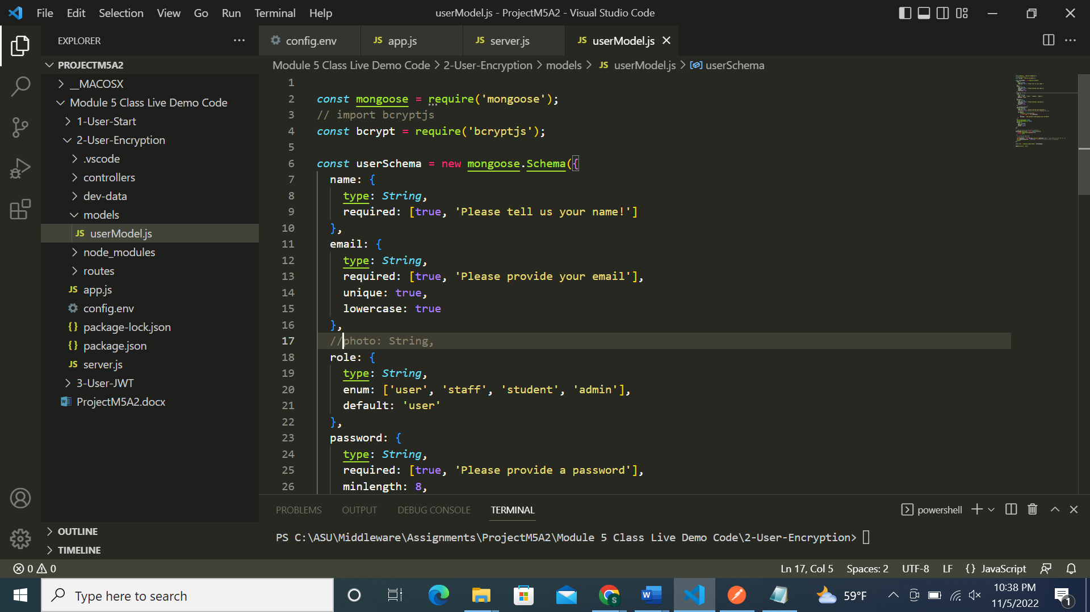

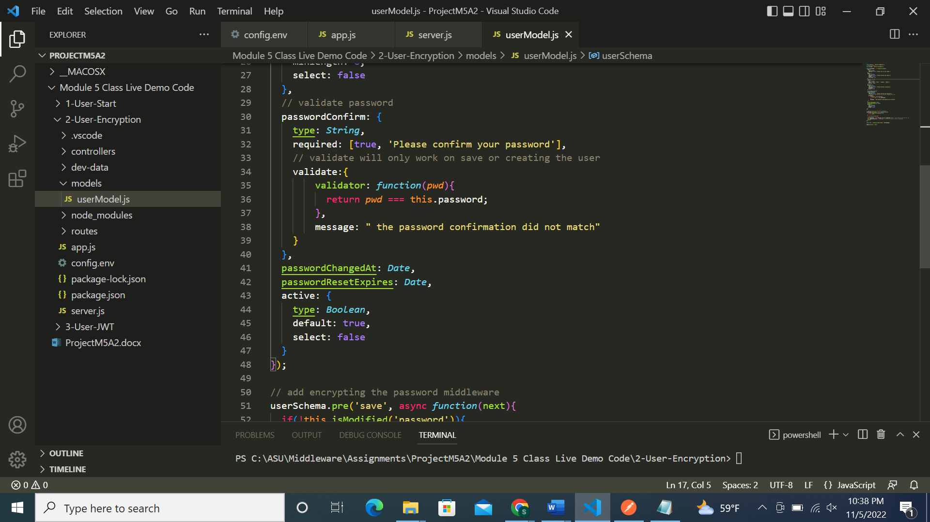

userRoutes.js file:

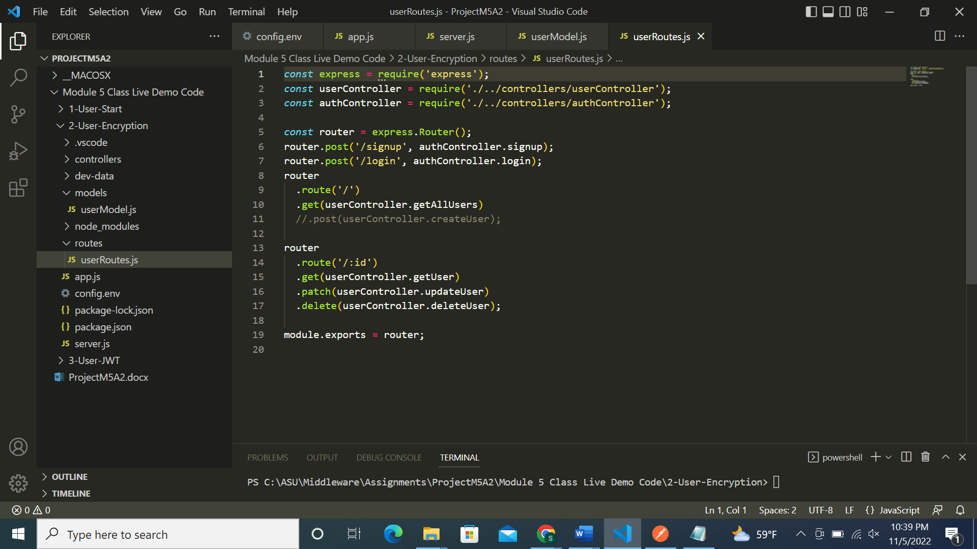

Successfully ran the code without errors:

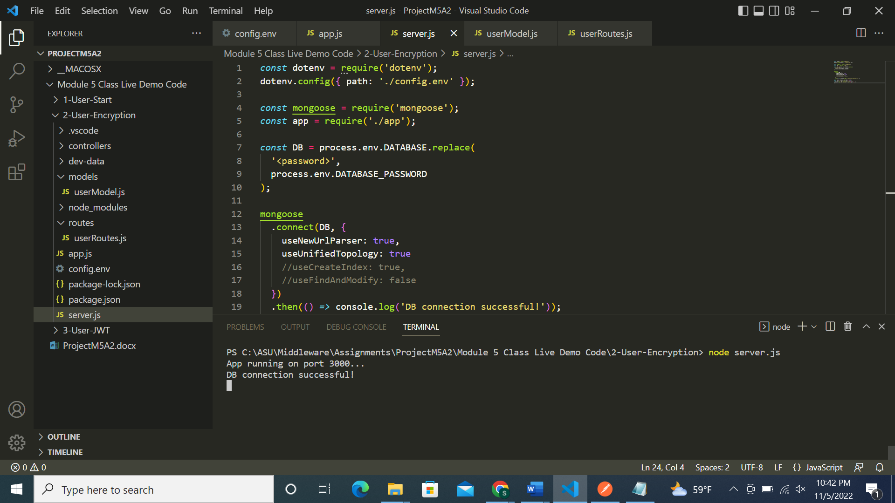

Screenshots of Postman requests:

1st record:

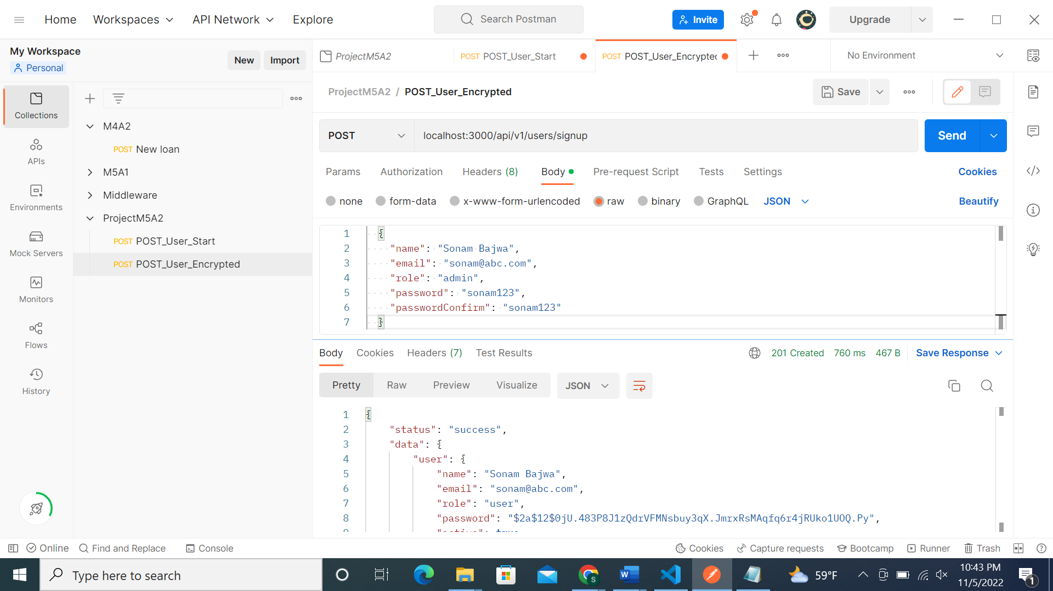

2nd record:

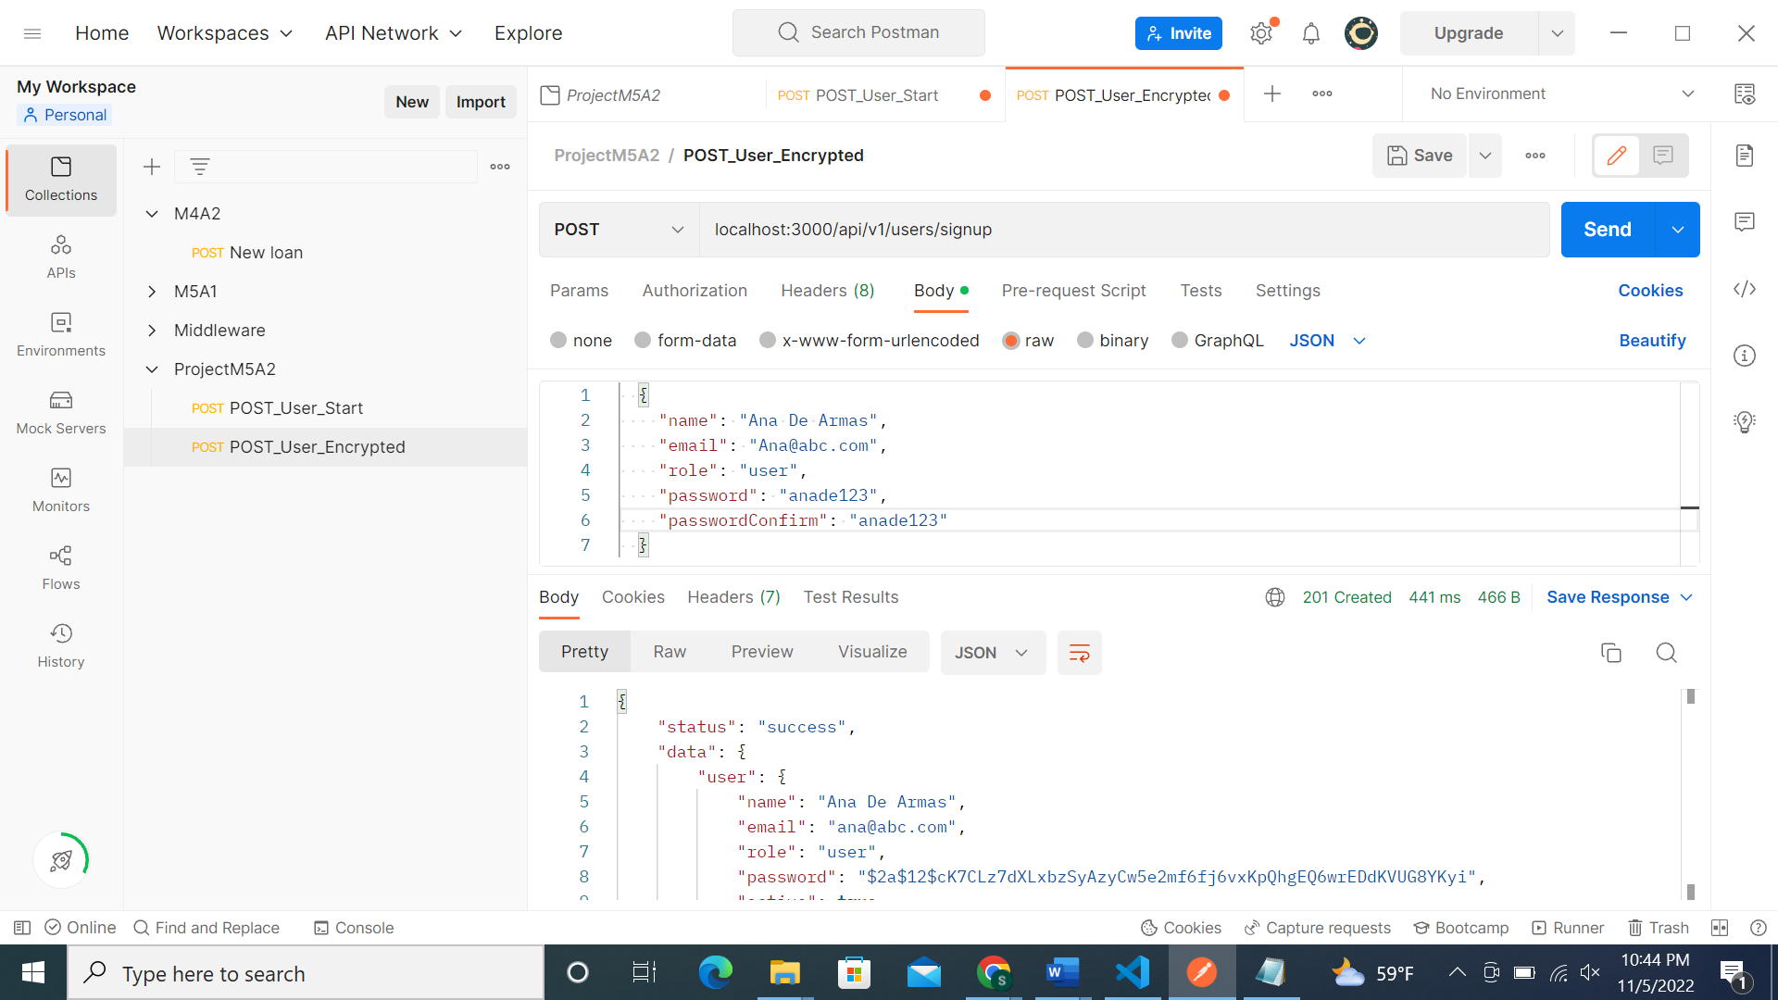

Similarly inserted 5 records:

MongoDB screenshot of password encrypted:

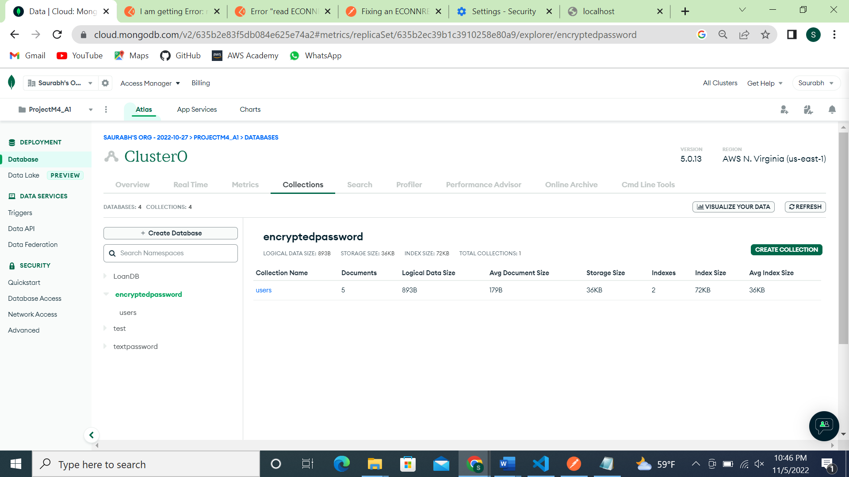

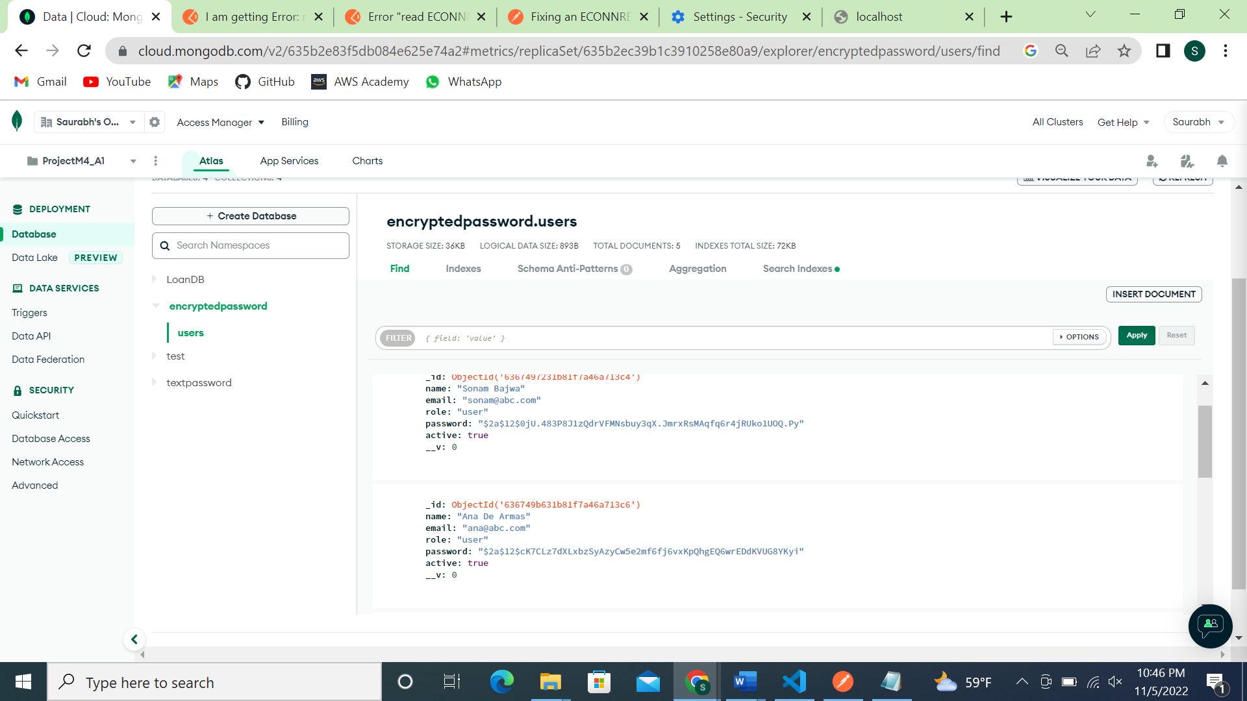

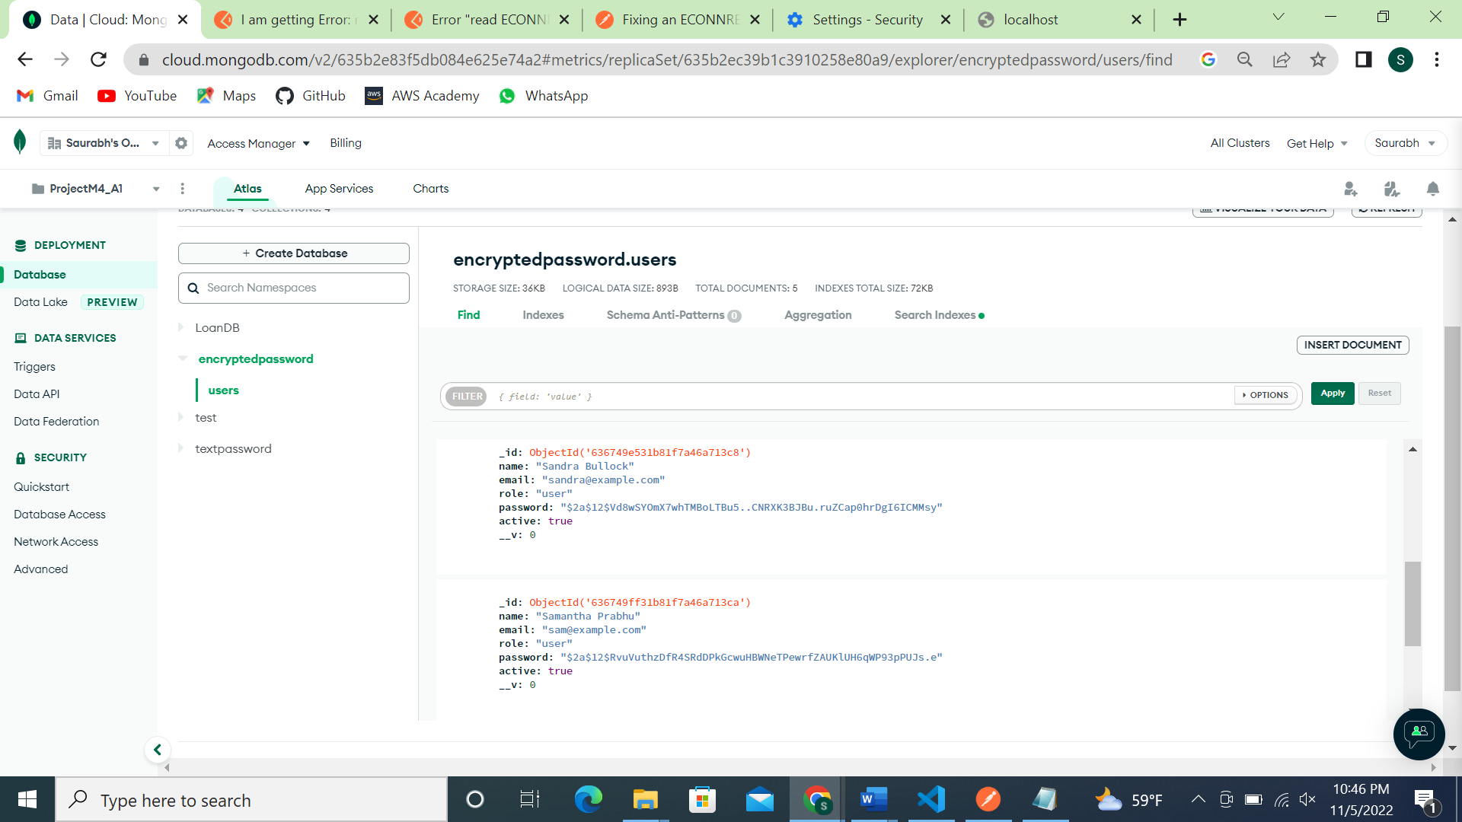

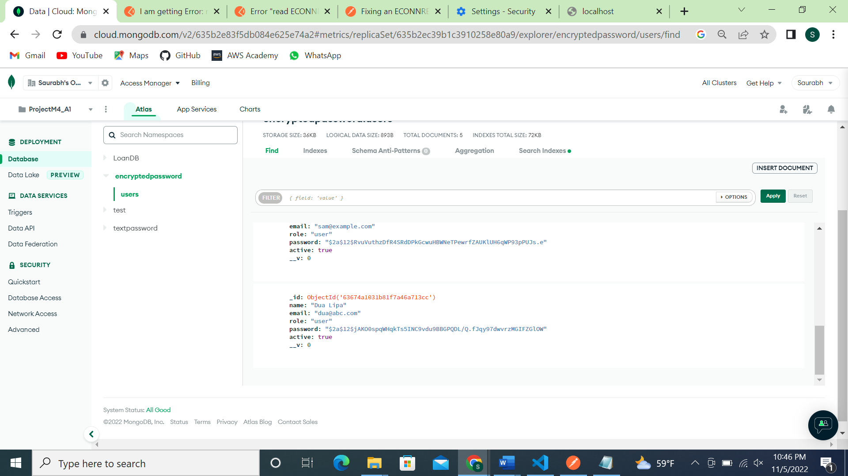

Part 3: JWT token:

Screenshots of code files:

Config.env file:

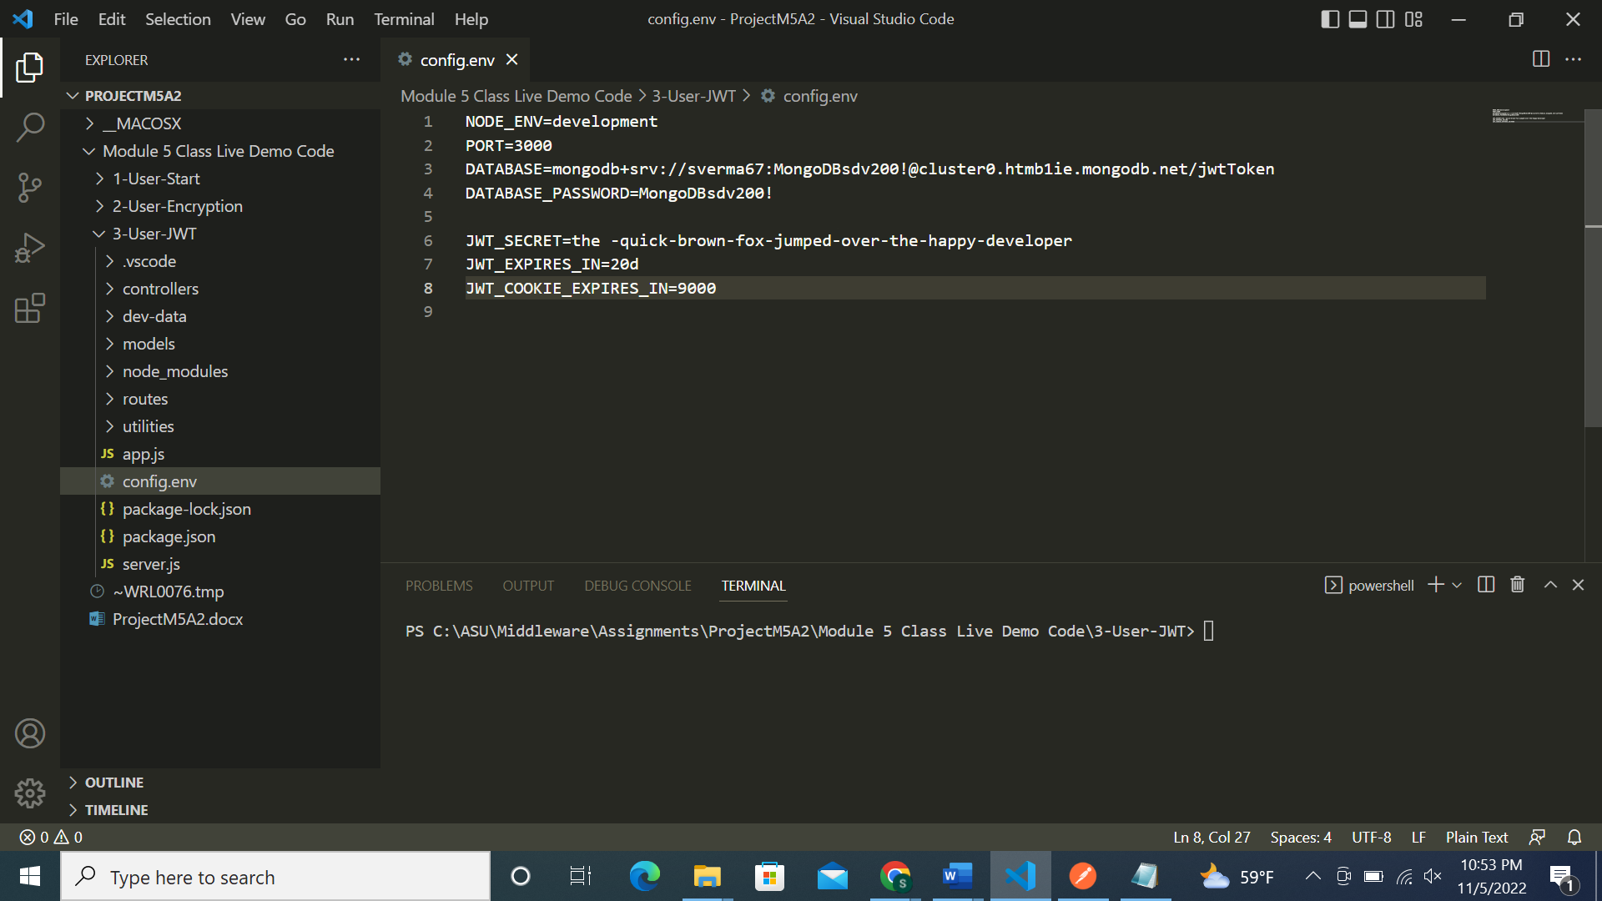

App.js file:

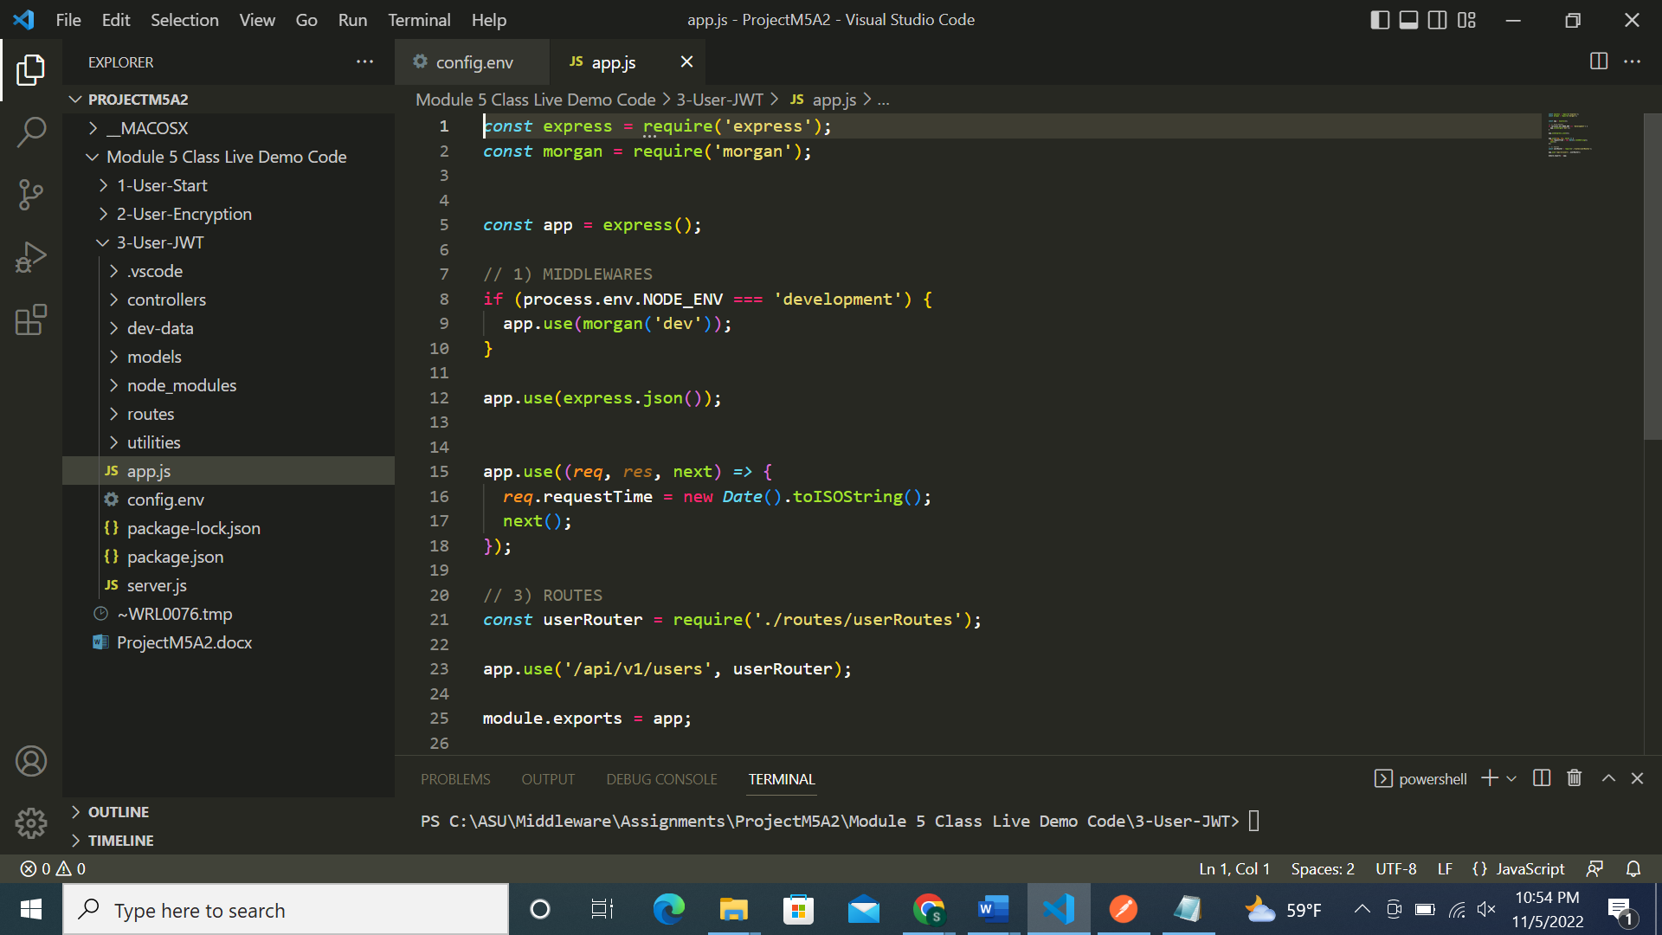

Usermodel.js file:

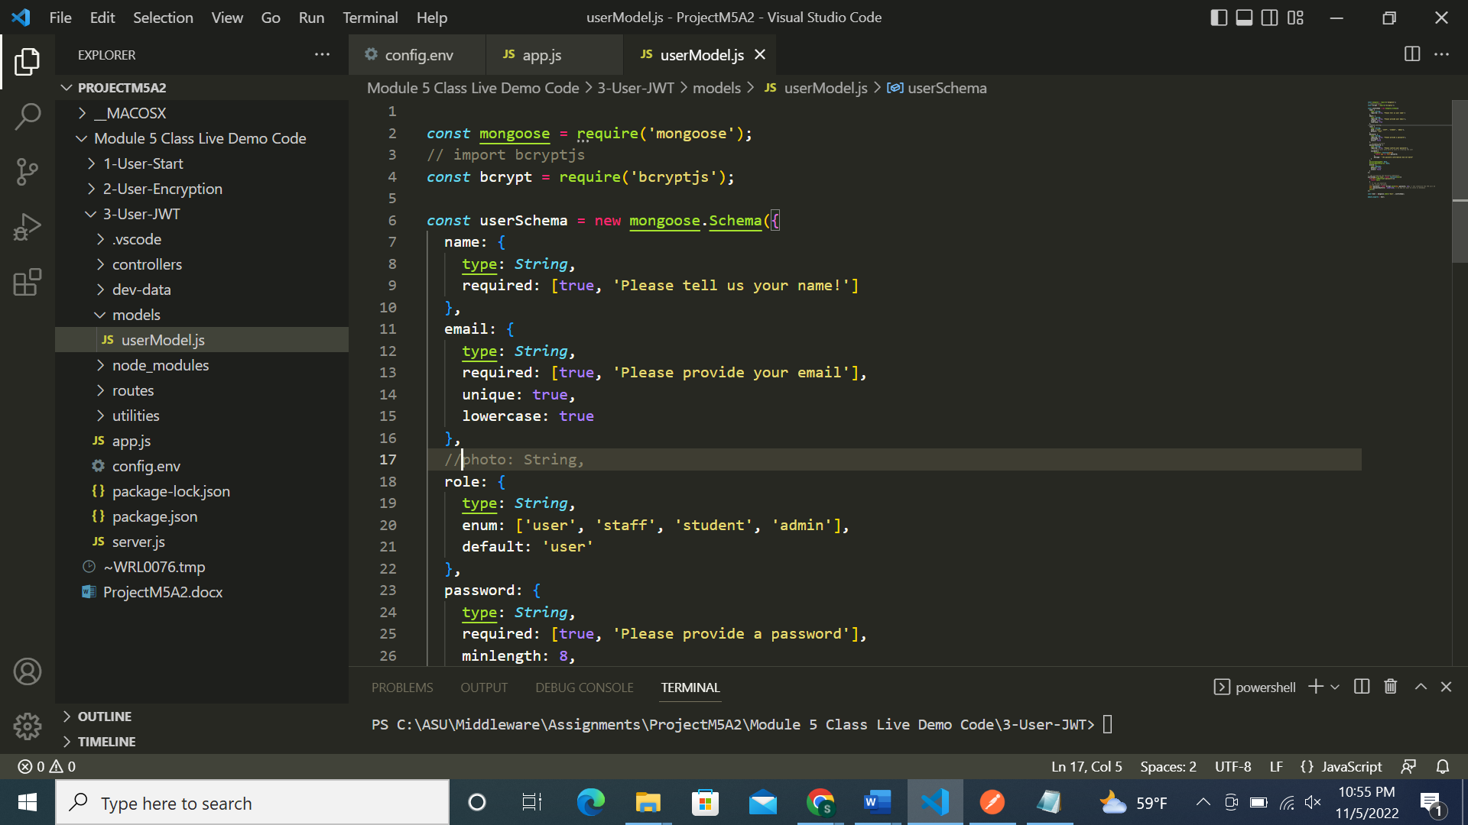

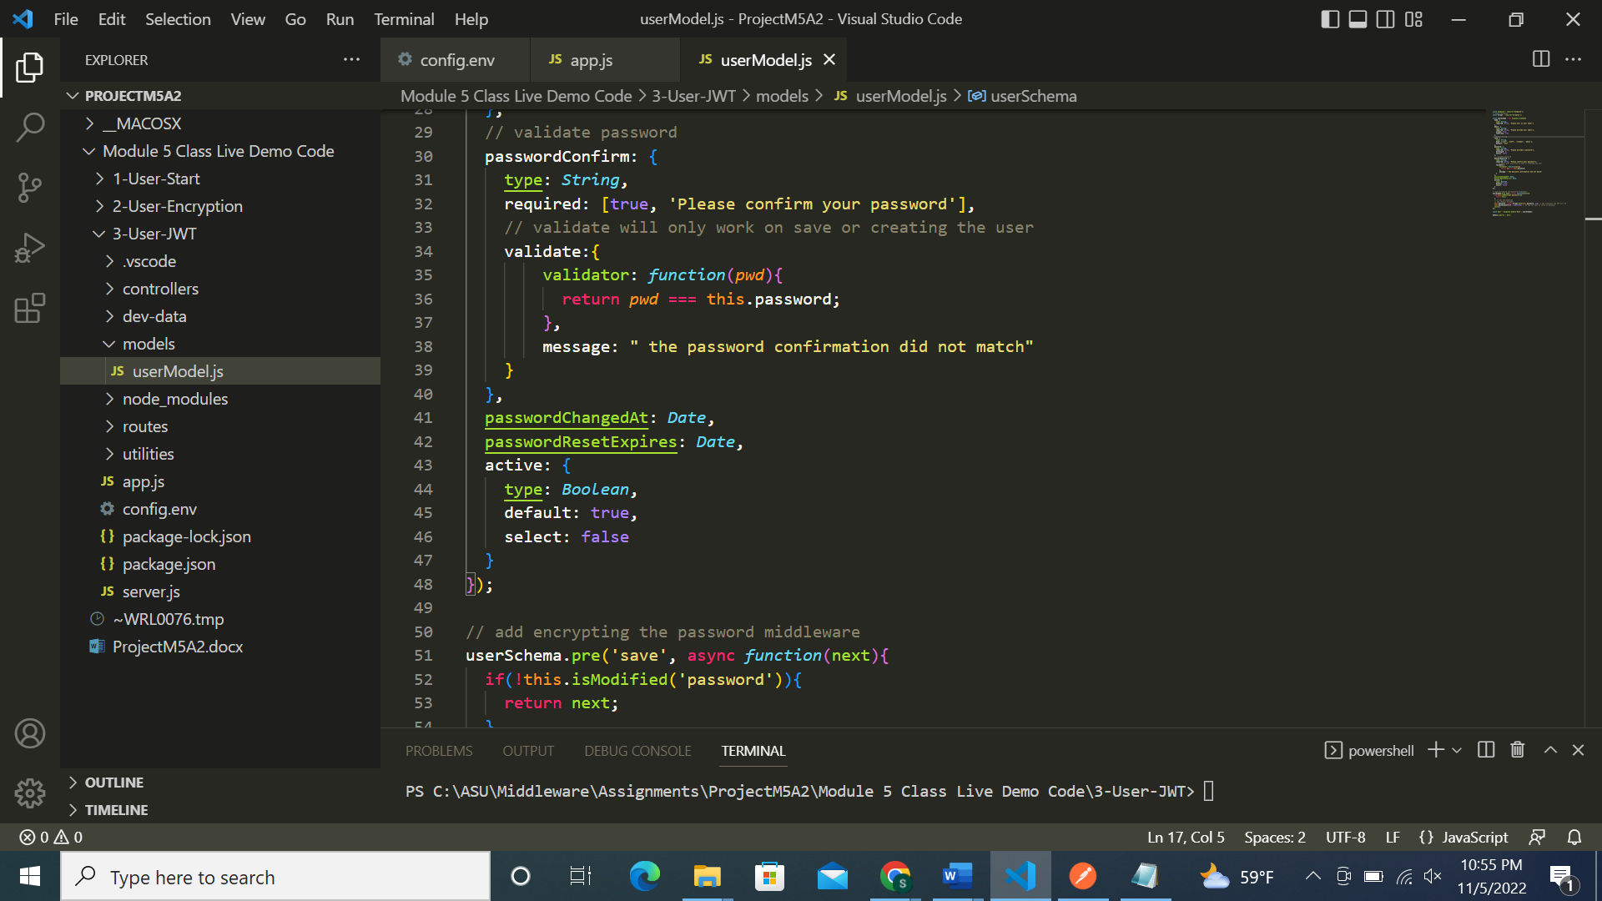

userRoutes.js file:

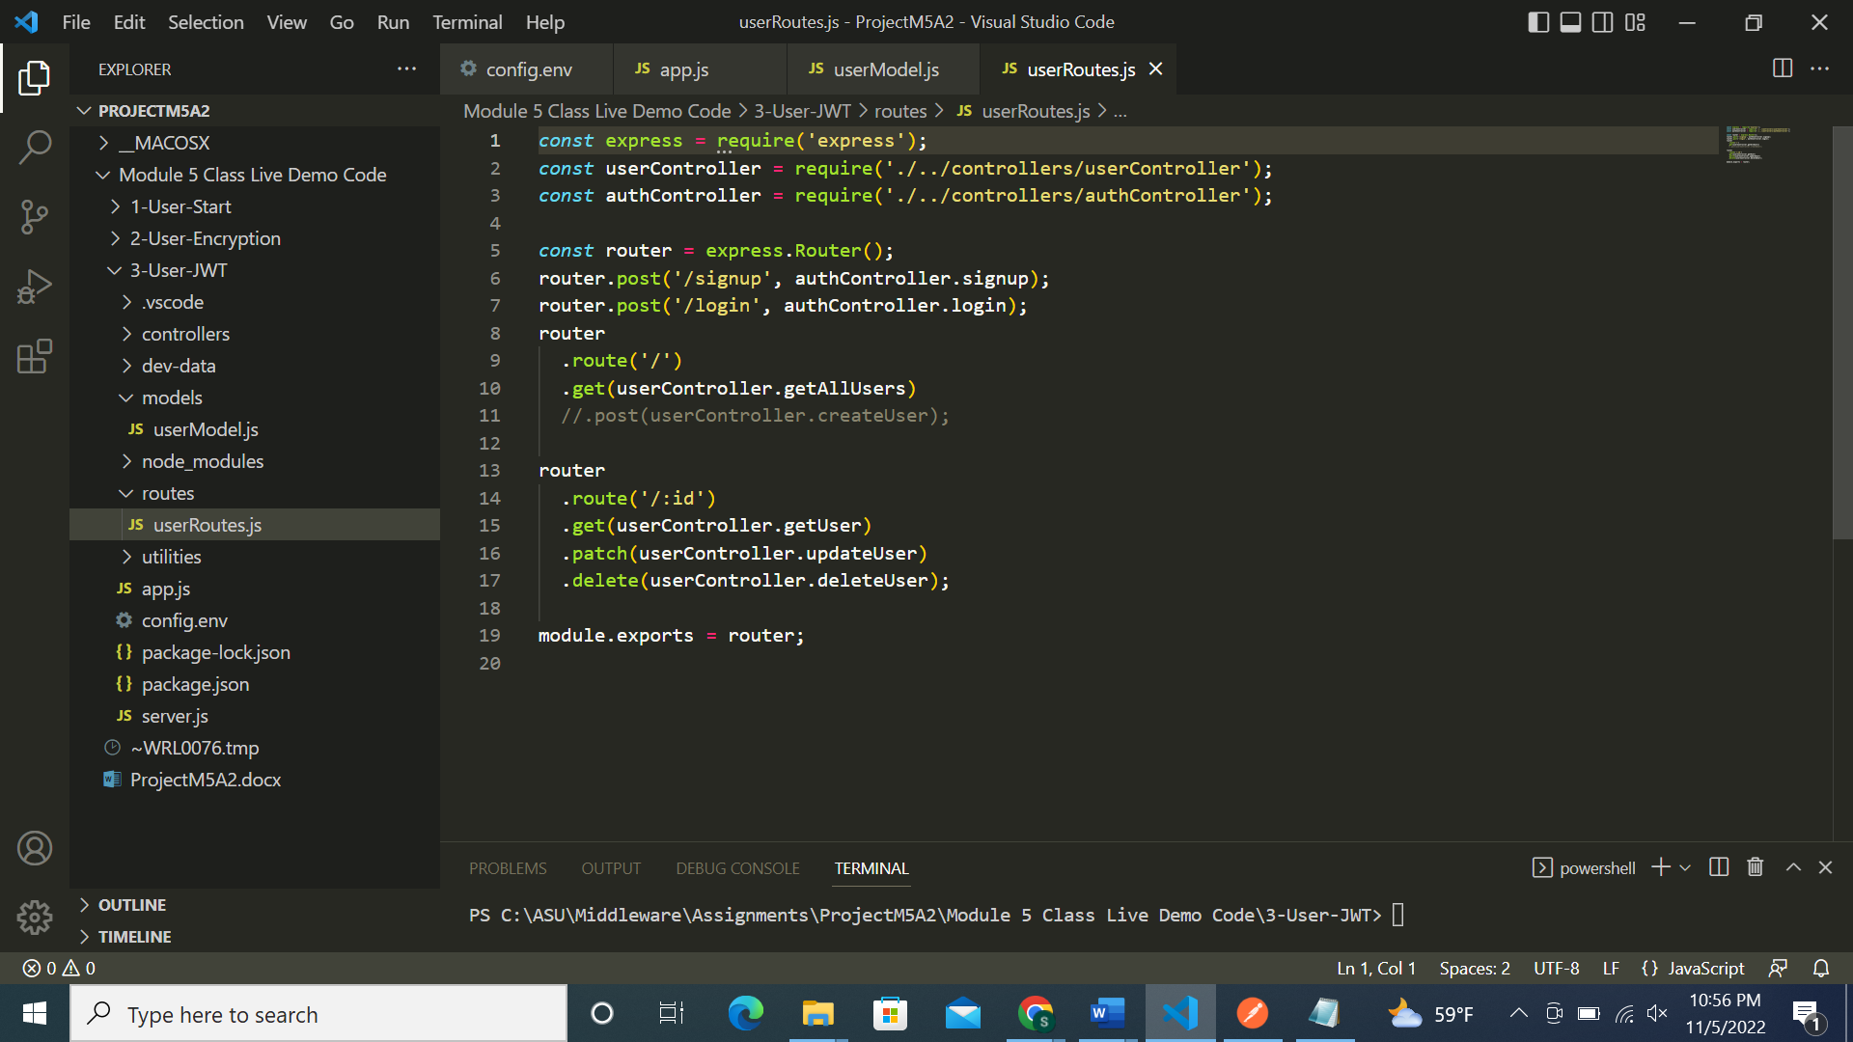

authController.js file:

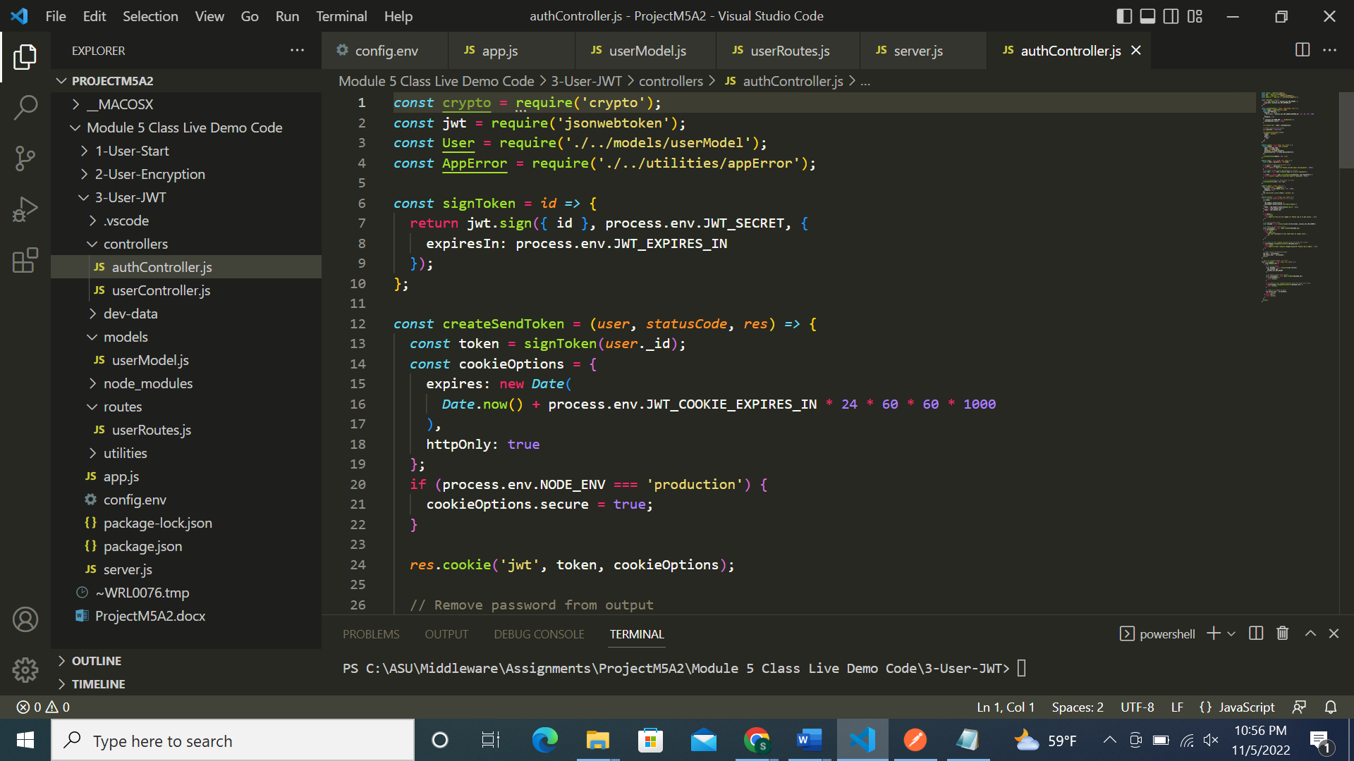

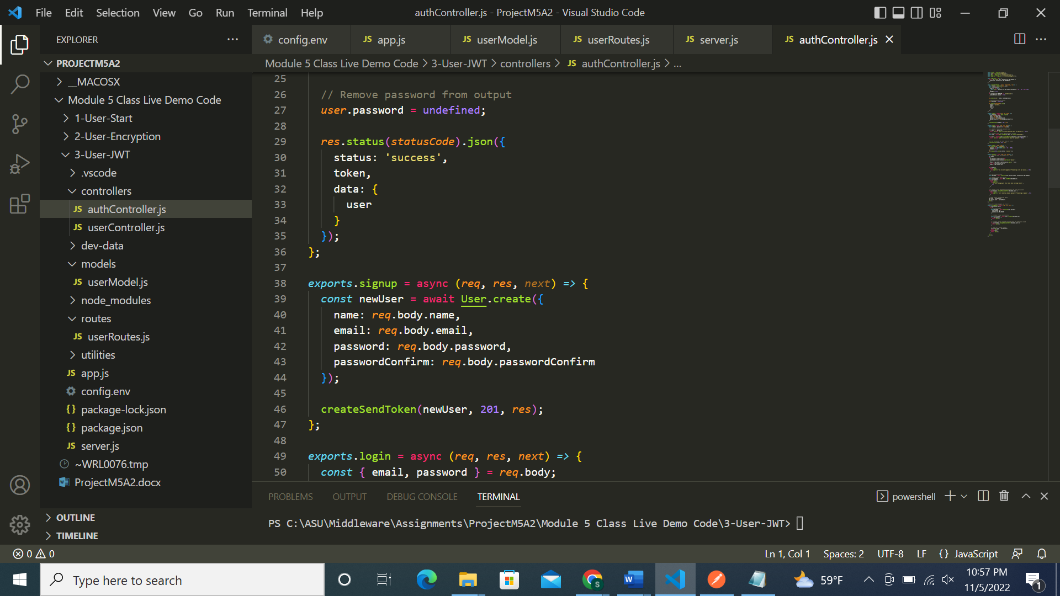

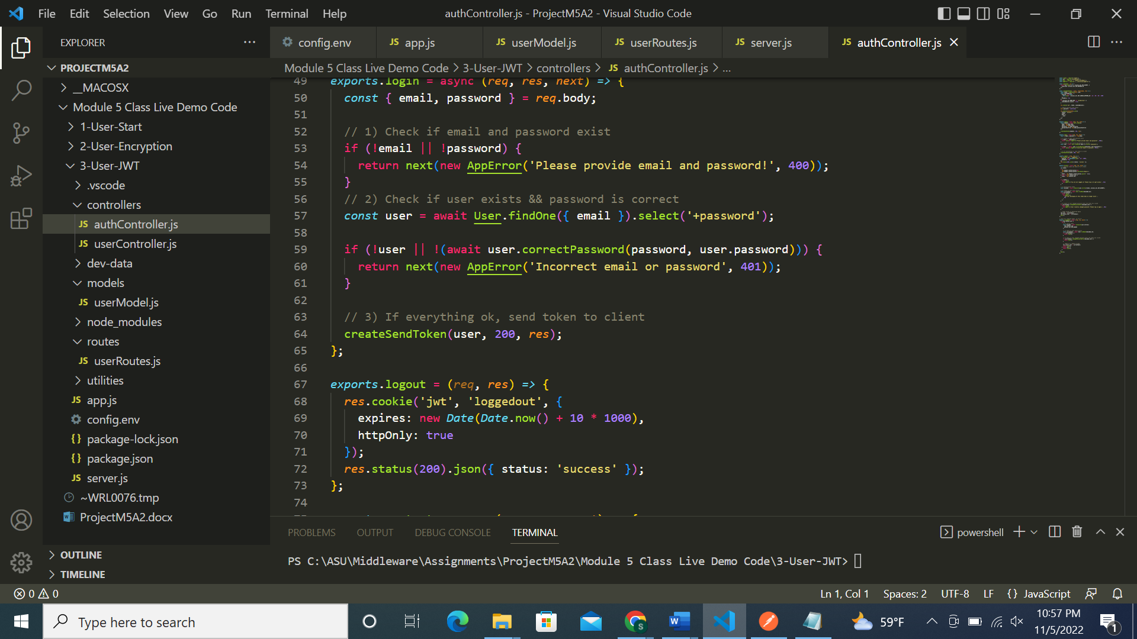

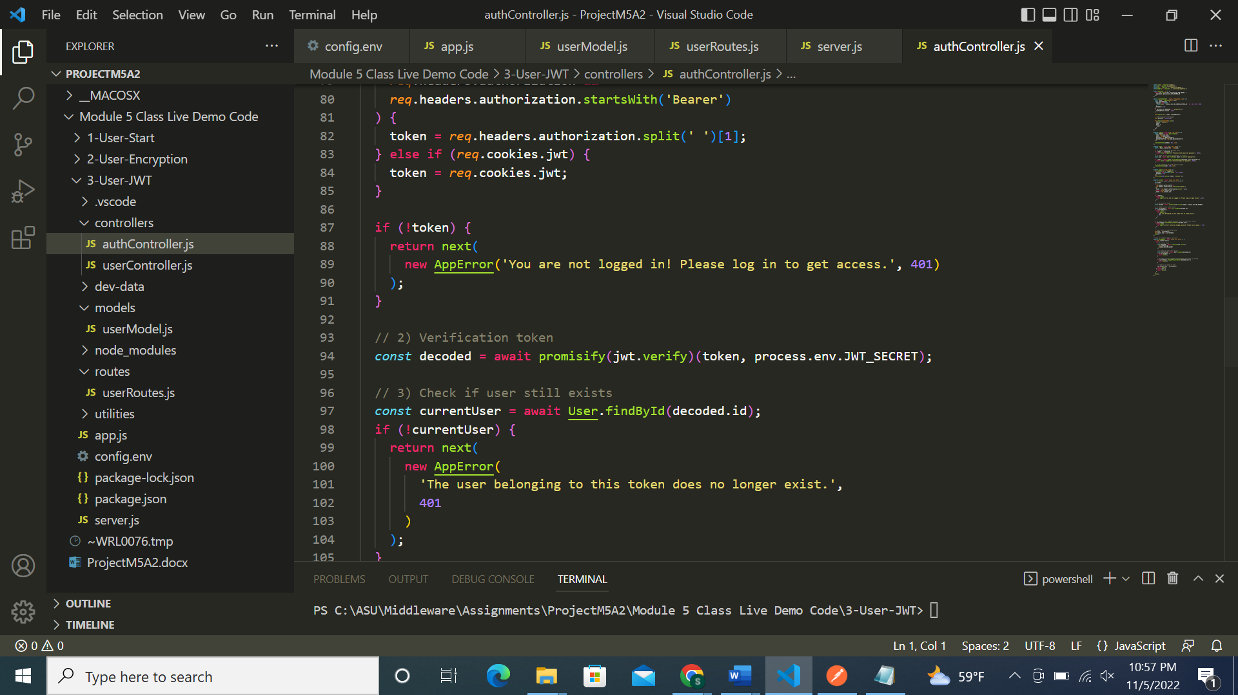

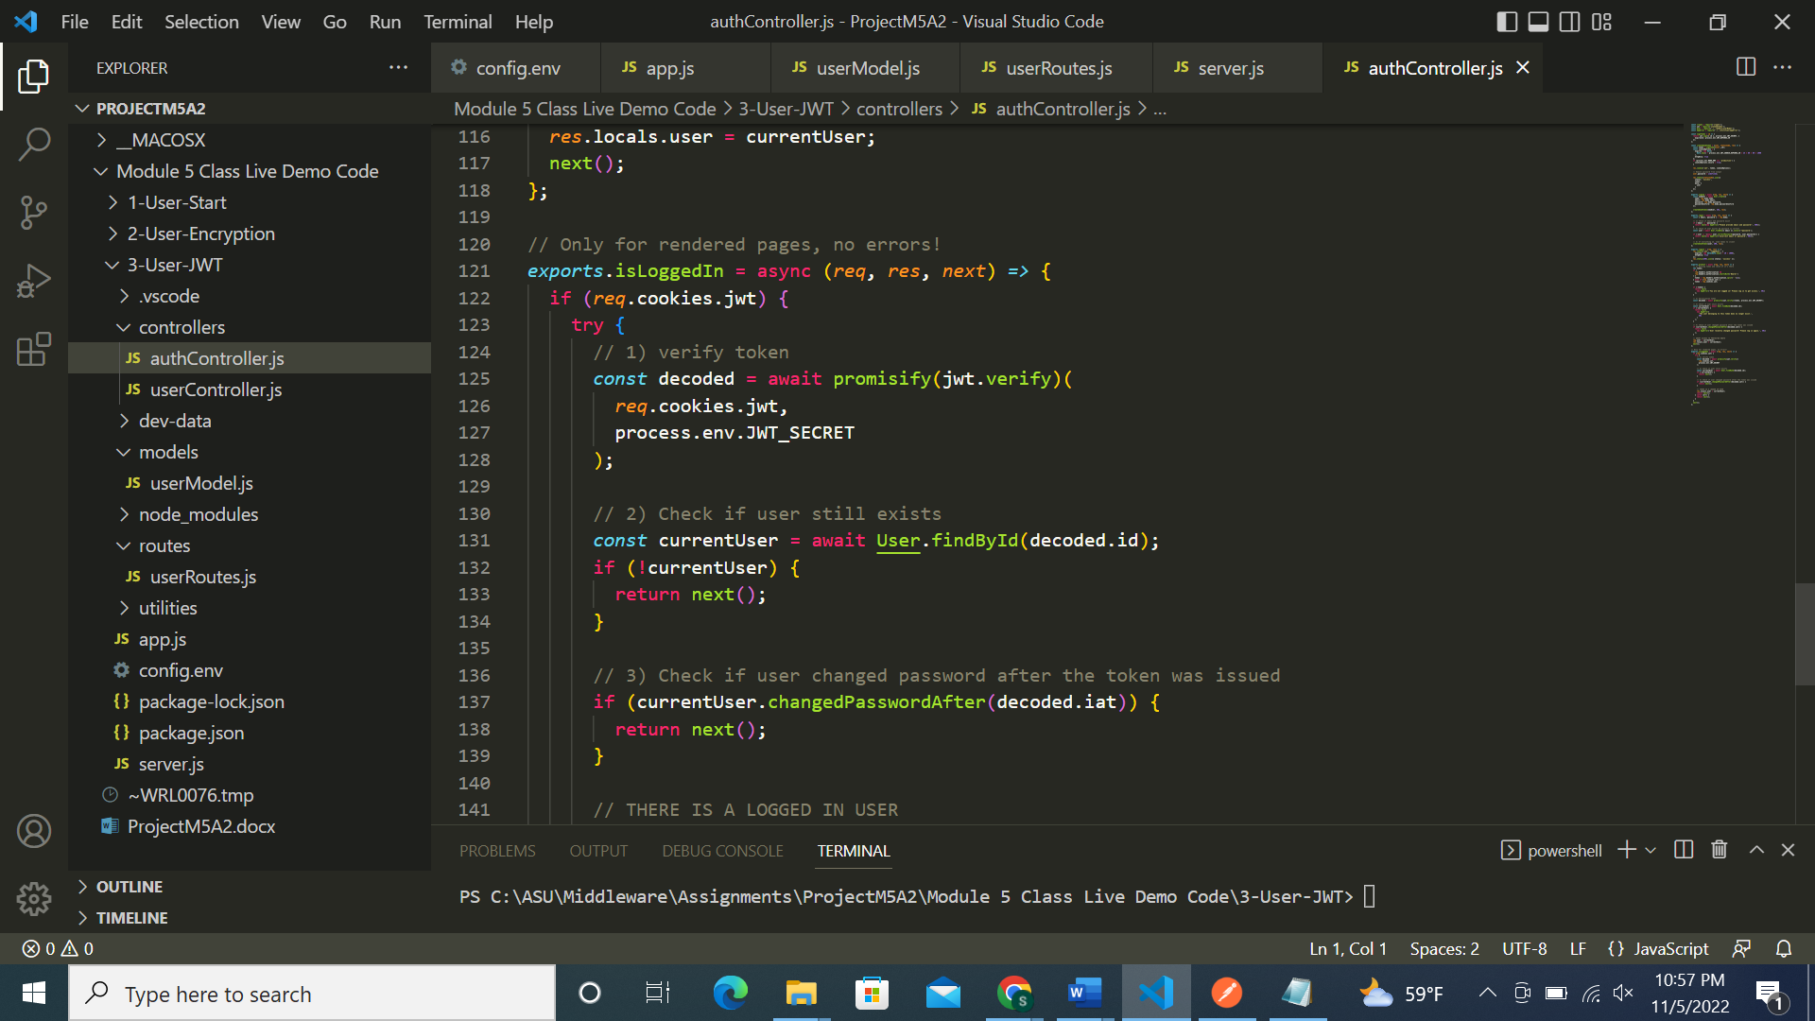

Server.js file:

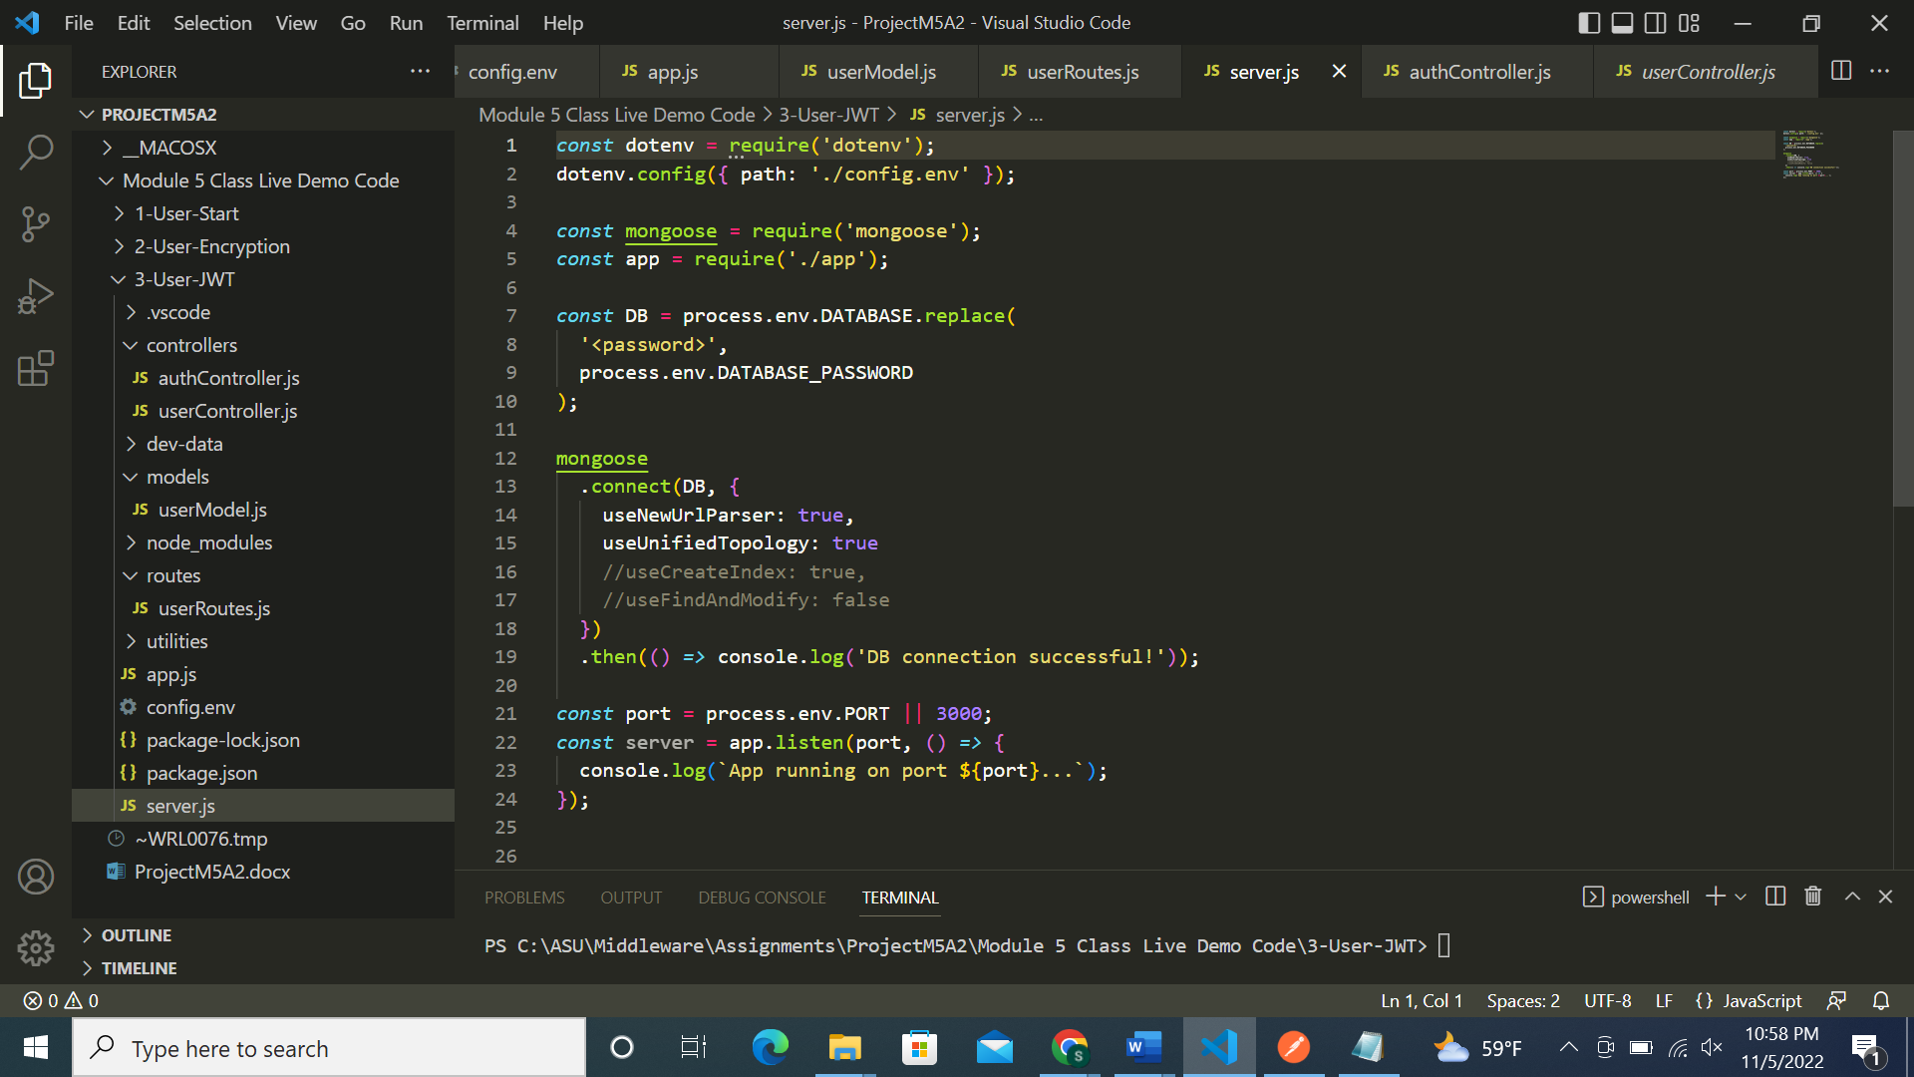

Successfully ran the code without any errors:

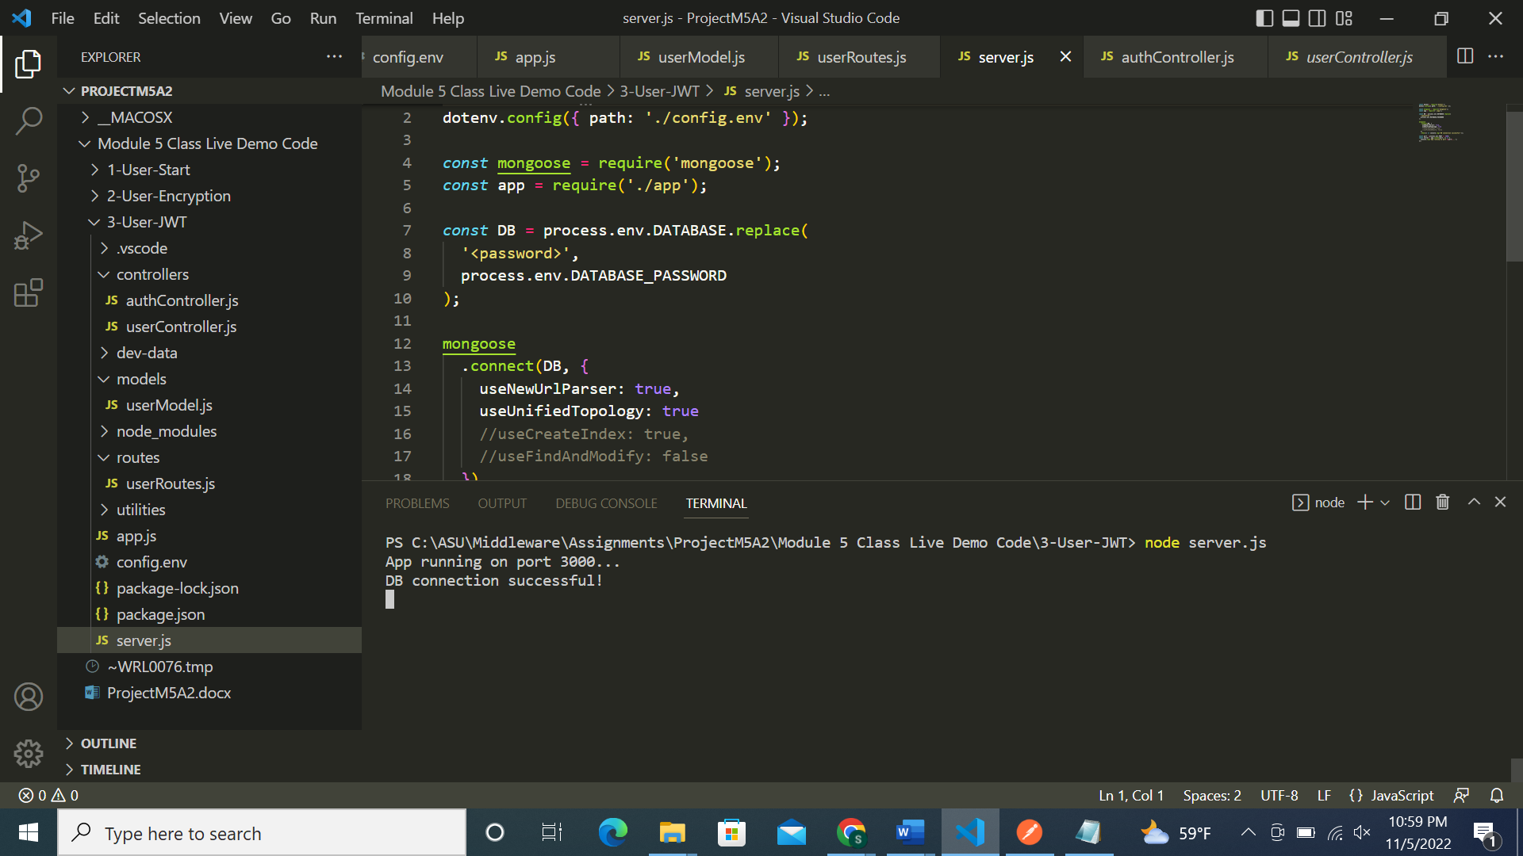

Screenshots of Postman requests:

1st record with JWT token:

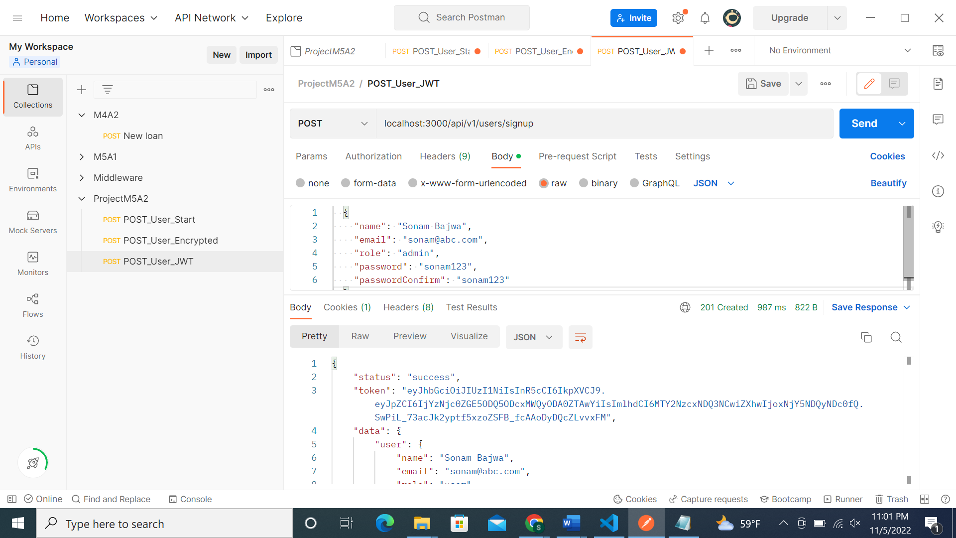

2nd record with JWT token:

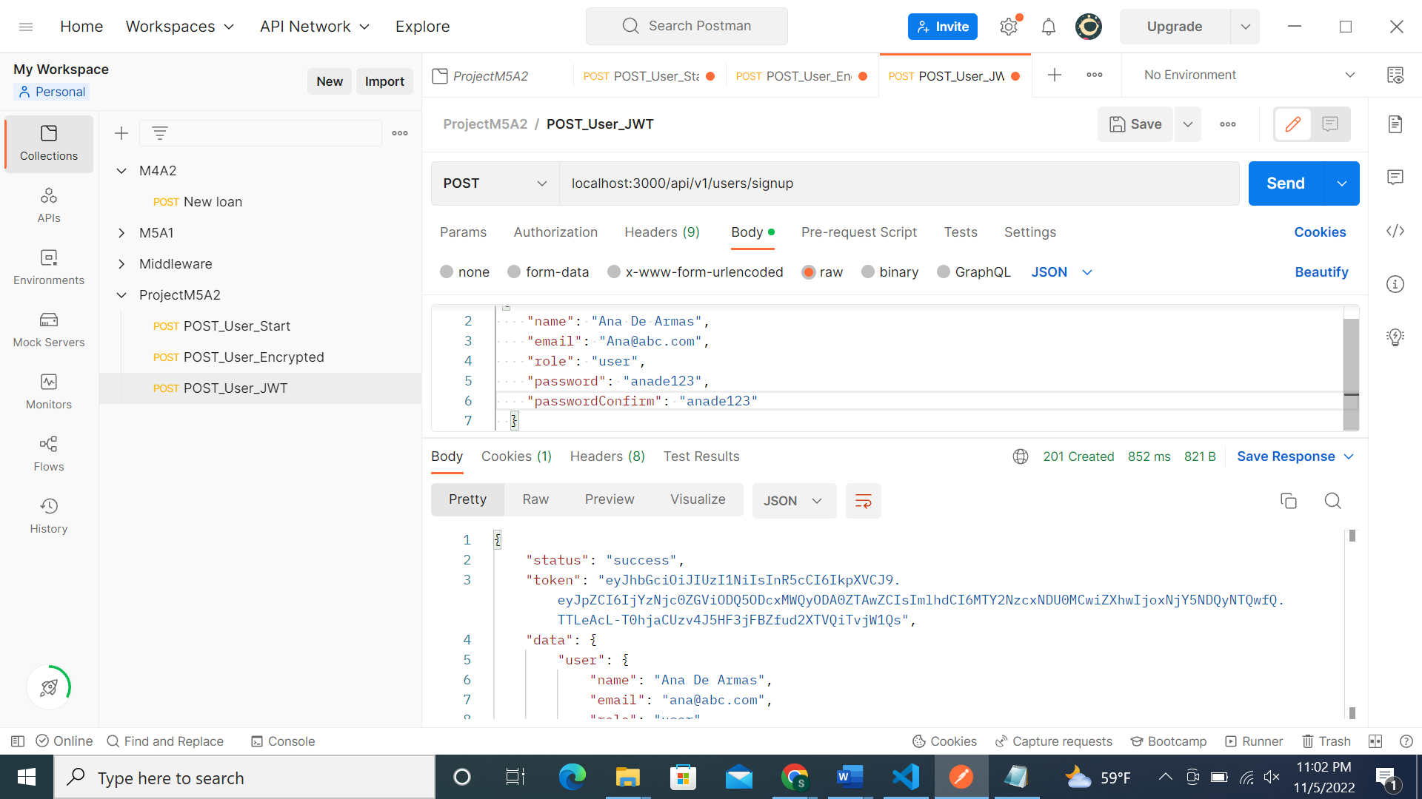

Similarly inserted 5 records:

MongoDB screenshot of 5 records in jwtToken table:

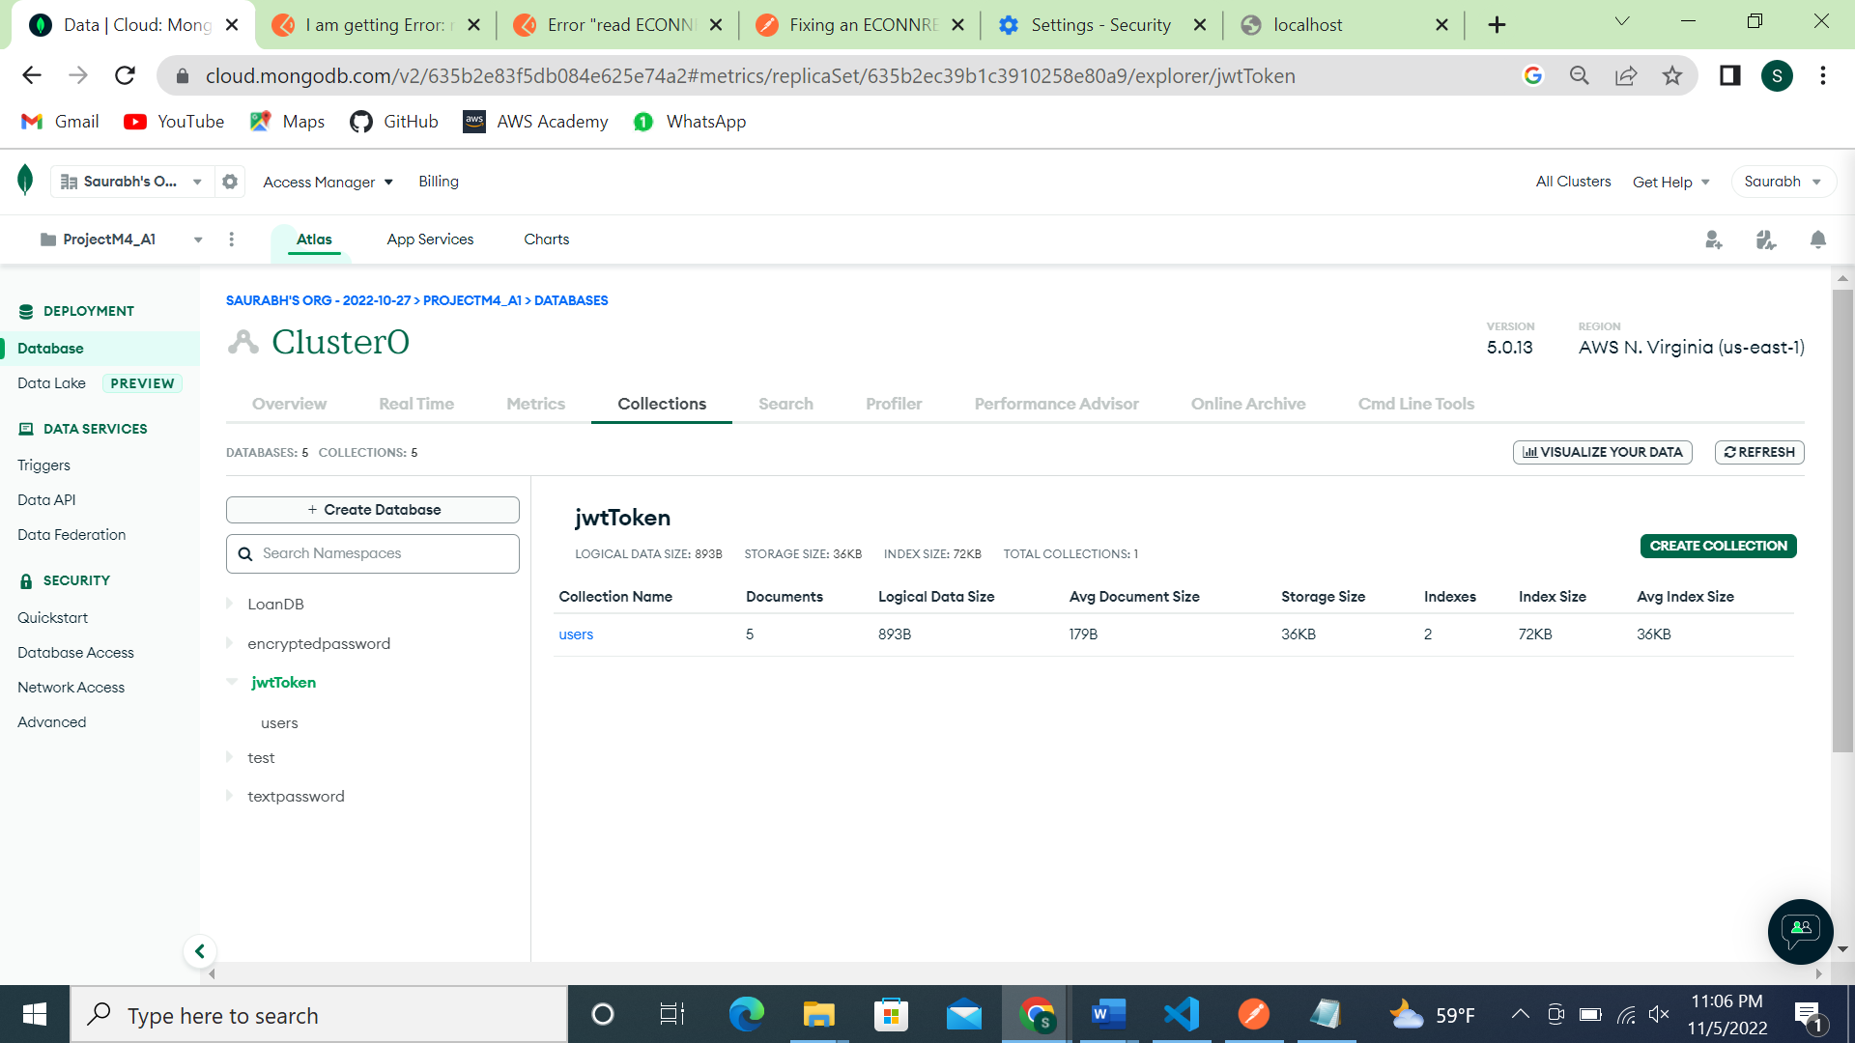

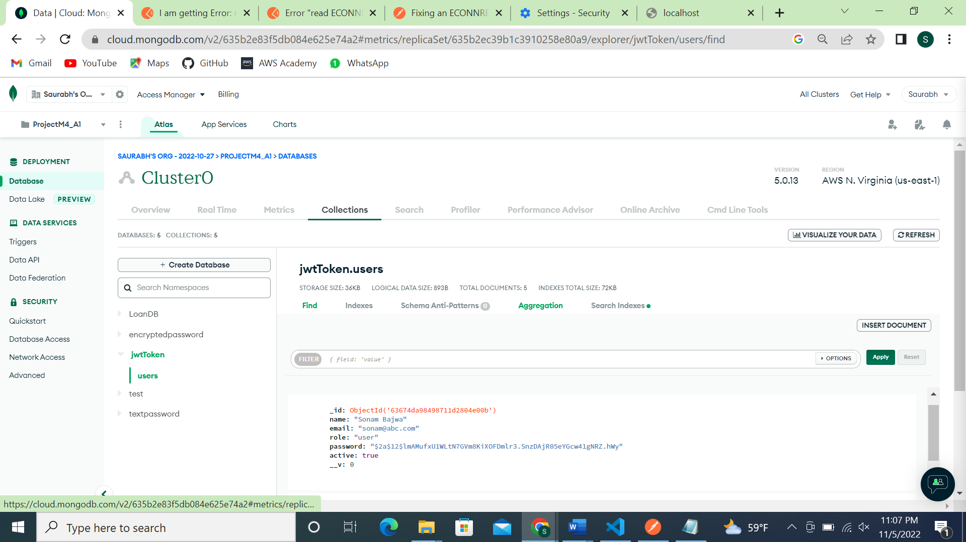

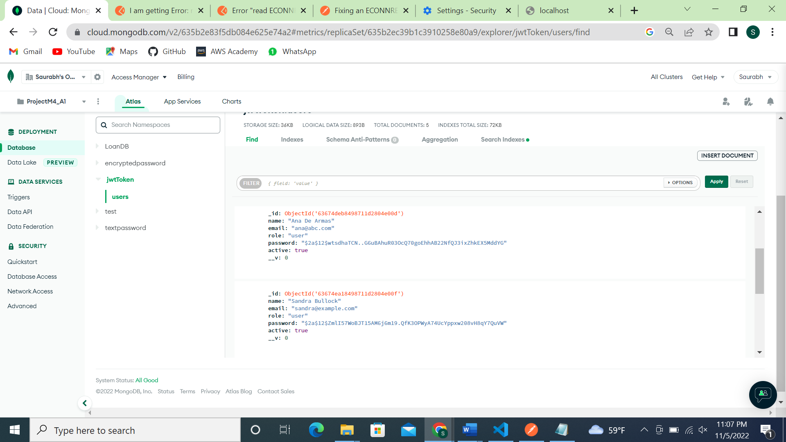

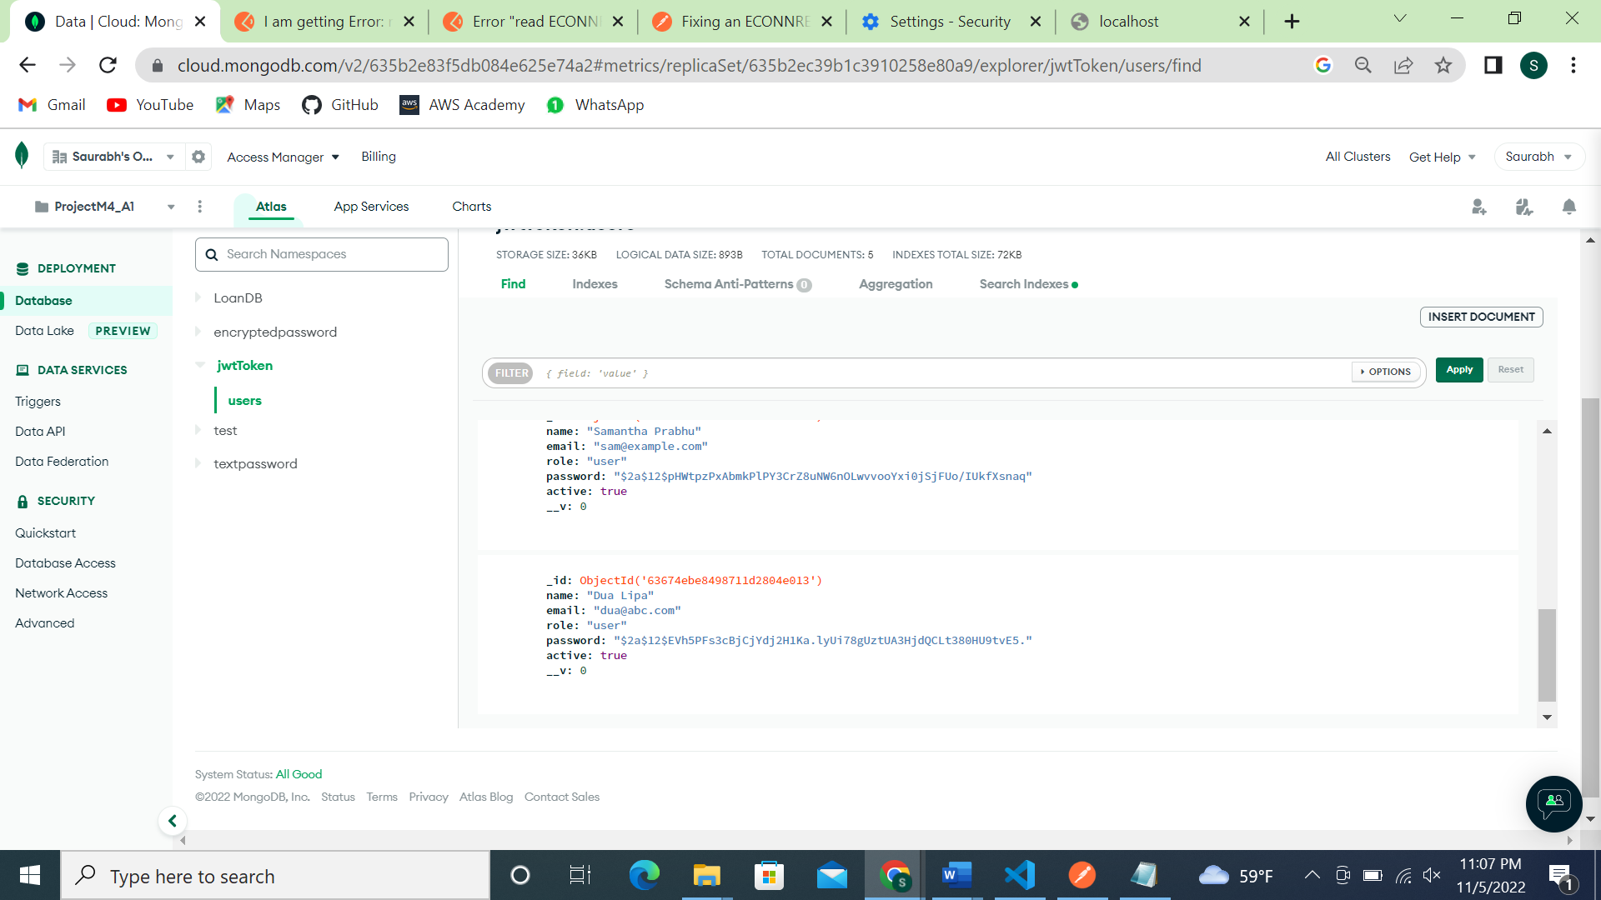

Screenshot of Postman requests exported:

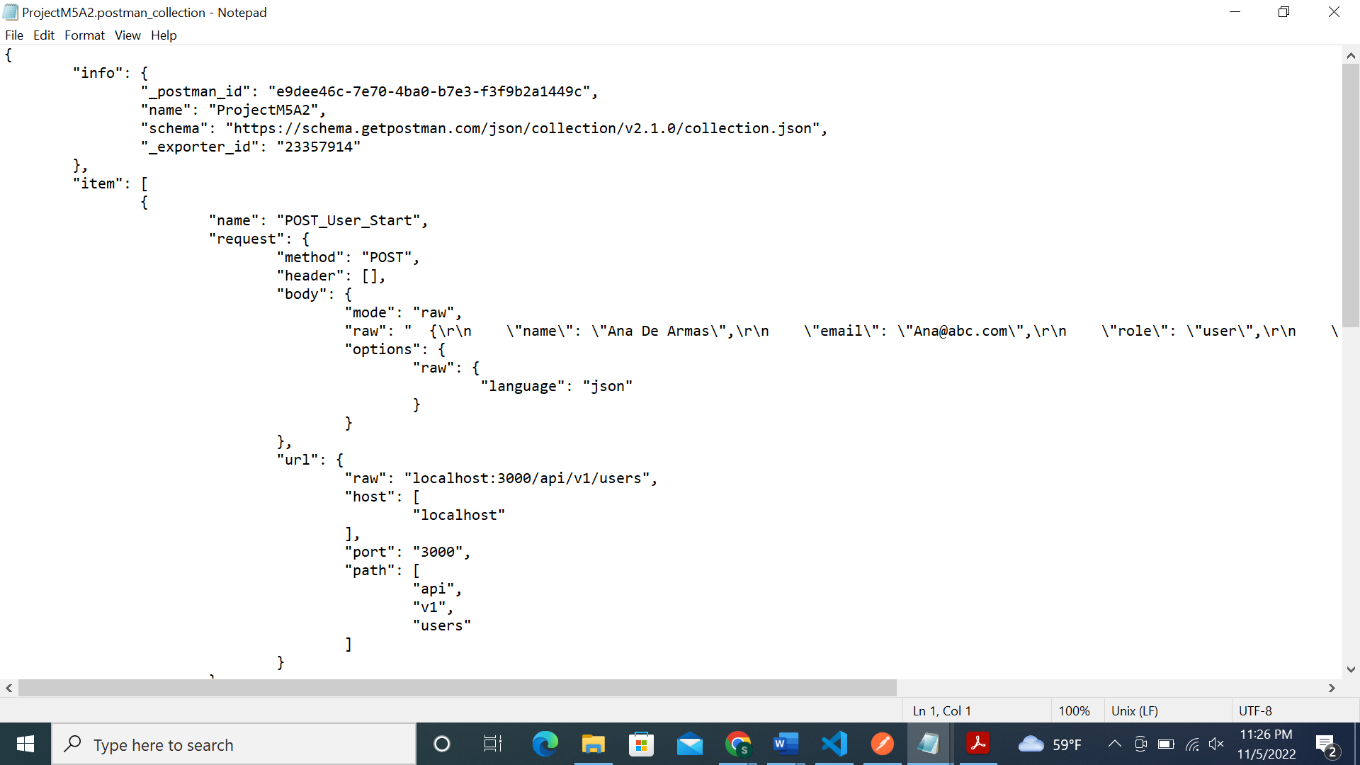

**JSON Web Token Authentication Flow:**

An open standard called JSON Web Token (JWT) (RFC 7519) outlines a condensed and independent method for securely transferring data between parties as a JSON object. The fact that this information is digitally signed allows for verification and confidence. JWTs can be signed using a public/private key pair using RSA or ECDSA or a secret (with the HMAC algorithm).

JWT Authenticarion flow chart:

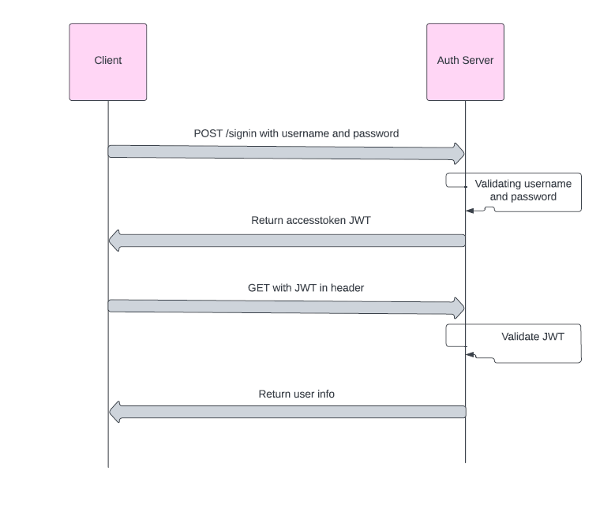

**References**

<https://jwt.io/introduction>

[JWT Flow chart](https://lucid.app/lucidchart/ba93ba2b-16cc-4a13-83aa-e2b18a2a028b/edit?beaconFlowId=3161EFF4A4FB8AB2&invitationId=inv_b0e6b702-3128-4260-9836-5c7fb1bd352e&page=0_0)

GitHub link: